Cloud computing

|  |  |
| --- | --- |
| On premise | Cloud computing |
| Pay in full or every resource you get (you can’t get the money back even if you don’t use the resource, unless you sell it) | Pay more if you use more, vice a versa for paying less |
| Need physical space to store servers or resources | Not needed |
| Need hardware team to manage resources | Not needed |
| Data security issues | Better data security |
| Less chances of data recovery | High chances of data recovery as there will be more than one back up servers running |
| Lack of flexibility (a change in technology may make our systems obsolete i.e., you might not be able to perform high end operations with a computer that is old) | High flexibility |
| Updates are to be done manually | Automatic updates are possible |
| Data access on remote locations is not easy | Remote Data access is easy |
| Setting up on premise takes lot of time | Set up is quick |

Cloud computing lets you store data over internet so that anyone with access to the network and/or resources can access data if connected to network

# Cloud computing is of 2 types:

## 1: deployment models (better explained in https://www.bmc.com/blogs/public-private-hybrid-cloud/)

### public model:

this is like travelling in a bus, you can use it based on your own needs, you pay based on the usage you do,

it is delivered via the internet (and is shared across organizations) made available to general public over the internet and is owned by a cloud provider

disadvantages:

**Lack of cost control**. The total cost of ownership (TCO) can rise exponentially for large-scale usage, specifically for midsize to large enterprises.

**Lack of security**. Public cloud is the least secure, by nature, so it isn’t best for sensitive mission-critical IT workloads.

**Minimal technical control**. Low visibility and control into the infrastructure may not meet your compliance needs.

### private model:

this is like owning a car, you pay huge money upfront and use it as per your need and you don’t have the need to pay any more money for using the service

this cloud infrastructure is operated exclusively by a **single organization** (may be third party), may exist on-premise of or off-premise

disadvantages:

**Price**. The private cloud is an expensive solution with a relatively high TCO compared to public cloud alternatives, especially for short-term use cases.

**Mobile difficulty**. Mobile users may have limited access to the private cloud considering the high security measures in place.

**Scalability depends**. The infrastructure may not offer high scalability to meet unpredictable demands if the cloud data center is limited to on-premise computing resources

### hybrid model

this is like having a taxi which has the feature of public model (bus), i.e, pay as long as you use, and also the feature of private model(car), i.e, pay some huge upfront amount and don’t pay anything else

used when you have both- sensitive information (which will be stored in private cloud) and non-sensitive information (which is to be stored on public cloud)

hybrid cloud=private cloud + public cloud (mostly used for the same organization AFAIK)

disadvantages:

**Price**. Toggling between public and private can be hard to track, resulting in wasteful spending.

**Management**. Strong compatibility and integration is required between cloud infrastructure spanning different locations and categories. This is a limitation with public cloud deployments, for which organizations lack direct control over the infrastructure.

**Added complexity**. Additional infrastructure complexity is introduced as organizations operate and manage an evolving mix of private and public cloud architecture

## 2: Service model

### 1: infrastructure as a service (IAAS)

If your company needs a virtual machine to perform operations

Provides basic computing infra structure

Offers services on *Pay for what you use* model

Providers: aws, azure, google compute engine

Users: IT administrators

### 2: platform as a service (PAAS)

If your company **needs platform for building software products** i.e., if you need **interface to write or upload a program**

Provides cloud platforms and run time environments for developing, testing, and managing applications

Allows deployment of applications without the need of underlying infrastructure

Users: software developers

### 3: Software as a service (SAAS)

If you need a product (which is developed) hosted in the cloud.

You get the credentials, then you can customize the application (if you want)

Cloud providers host and manage the software application through *Pay as You Go pricing* model

You don’t have to manage anything

Users: End users

Example: PUBG

### Comparing Iaas, Paas, Saas

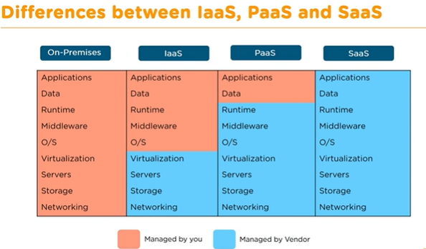

To understand the above example better observe the below image

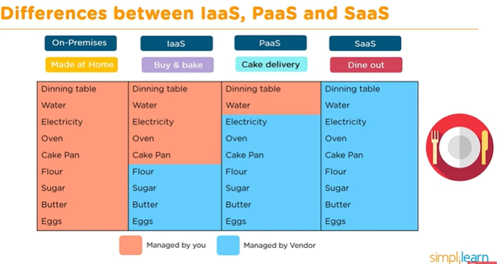

# Different types of cloud providers:

* amazon aws
  + provides services over internet
  + can deploy any type of application
  + uses **pay for what you use** model
* google cloud Platform
* IBM cloud
* Microsoft Azure
* VMWare
* Digital Ocean

# Life cycle of cloud computing solution with respect to AWS:

## Define the purpose:

Understand the business requirement and what type of applications to run on the cloud

## Define the hardware:

Choose a compute service which provides you the right support in resizing the compute capacity in the cloud to run an application

Some examples

EC2 (Elastic Compute Cloud): a web service that provides a **secure and resizable(elastic)** **compute capacity** in the cloud, can add as many services as you want

Lambda: for server less computing

ECS(Elastic Container Services): for containerized service

## Define the storage:

Choose a storage service where you can **backup** and **archive data within the cloud or over the internet**

S3 (Simple Storage Service): for backup, used to retrieve any amount of data any time on the web

EFS

Glacier: for archival

## Define network:

Define a network that delivers data, videos, applications with low latency and high transfer speed

Some examples

Vpc: for network

Route 53: for DNS

Direct Connect: for P2P (peer to peer) line from office to aws data center

## Define Security:

Set up security service which enables user authentication or provides access to a set of users for aws resources

Some examples

IAM: for authentication and authorization

KMS: encryption service for data at rest

Cognito

## Define management and process tools:

You can have complete control over AWS environment by running management tools which monitor aws resources and applications running on AWS platform

Some examples

Cloud watch: for monitoring

Autoscaling: for being elastic

Cloud formation: for deployment

## Testing the process:

Verify the process using AWS developer tools where you can build, test, and deploy the code quickly

Code Star

Code build

Code Pipeline

# Analytics:

Analyze and visualize data by using the analytics services where you can start querying data and get instant results

Some examples

Athena

EMR – elastic map reduce

Cloud search

# Google cloud related information:

Peak load provisioning: procure infrastructure for peak load- a traditional challenge with physical or on-premise storage

A small story- let us think there are a group of startups and one of them got popular overnight and got hundreds and thousands of downloads, to cater the needs, there are 2 things that can be done:

1. Get peak load provisioning after popularity (dis adv- not a easy process and might take weeks or months and is a costly procedure)
2. Anticipating success and get peak load provisioning before hand

Disadvantages

Start up may not become successful in future

Lot of cost involved

On premise needs **resource provisioning,** whereas cloud offers **on demand resource provisioning** also called as **elasticity**

**Advantages of cloud approach:**

No need to guess capacity

**Why GCP:**

One of top 3 cloud providers

Cleanest cloud

Provides several services (200+)

Highly performant, reliable, secure

Runs on 100% renewable energy

Providers services to more than 8 applications that run with more than 1 billion users

**Regions and zones:**

To have increased availability(backup servers) and fast services(if data center is far away from the place service is needed, then the latency(speed at which the service is served)will be high) we need regions and zones

Google cloud platform has 20+ regions and 70+ zones as of 2022

Advantages of regions and zones:

It increases **availability**

Low latency

Global footprint (an Indian app can be made available to us people seamlessly)

Adhere to government regulations (data privacy issues of its citizens)

**Region:** specific geographical location to host your resources

**Zones:** regions are further divided into zones, i.e., 3 zones in one region, zones give increased availability and fault tolerances. Each zone has one or more clusters i.e., data centers. Zones in a region have low latency i.e., you can application in one region and data related to it in another region and even though the application performs at almost full speed as data transfer among regions have low latency

Whenever you want to deploy applications, you need servers, whenever you want to deploy applications in the **cloud** you need **virtual servers, google compute engine (GCE)** enables you to **provision and manage** this in **google cloud. Virtual machines** are also called as **virtual servers**

**GCE features:**

Create and manage lifecycle (includes start, stop, restart, and terminate) of Virtual machine instances.

Performs load balancing and auto scaling for multiple VM instances

Attach storage to your VM instances

Manage network connectivity and configuration (assigning IP address to VM and sending requests to it) for your virtual machines

Machine configuration section (which can come when you try to create a new instance in GCE) deals with assigning desired configurations for the VM based on our requirements, it offers a set of **machine families** as below:

General purpose

These are used for machines which have only requirement of common workloads, these are optimized for cost

Compute optimized

High performance machine types for compute intensive workloads

Memory optimized

Large memory machine types for memory intensive workloads

GPU

Optimized for ML, high performance computing and visualization workloads

There are couple of important choices we made while creating virtual machine

1. Choosing a Hardware, we chose (which is nothing but the machine families discussed above)

Machine families have 2 important considerations:

* Machine family- different machine families are present to represent different workloads (already discussed above in brief)
  + General performance (E2, N2, N2D, N1)- gives best price performance ratio, used for small-medium databases, web and application servers, Dev environments
  + Memory Optimized (M2, M1): ultra high memory workloads (when you want lot of ram), ex:large in memory databases and large in memory analytics
  + Compute Optimized (C2): compute intensive workloads, ex: gaming applications
* Machine type- within each machine family, we have variety of machine types
  + Ex: e2-standard-2, e2-standard-4, e2-standard-8, e2-standard-16 and so on,,, lets take example of e2-standard-2, breaking it down e2-> machine type family, standard->type of workload, 2-> CPU count, memory disk and networking capabilities increase with CPU count

1. Choosing a software and OS:
   1. An OS is selected by selecting the corresponding image,

Public images: these images can be open source or can be the one being maintained by google or by third party vendors

Custom images: created by us for project purpose

Internal and External IP addresses:

An external IP is something which we use to communicate to the application from the outside (internet addressable)

An internal IP address are internal to a corporate network

You cannot have 2 resources with same IP address, (however 2 different corporate networks with same internal IP address can have resources with same internal (private) IP address)

## Preemptible VM’s:

Short lived, cheaper (up to 80%) compute instances

Can be stopped by GCP anytime within 24 hours

Instances get 30 sec prior notification (in case, if you need to save data or anything in VM)

Use preempt VM’s if:

Application is fault tolerant (you can start/stop them anytime)

You are very cost sensitive

your workload is not immediate (ex: non immediate batch programs-batch programs to be run in next 15 days)

Restrictions:

Not always available

No SLA and can not be migrated to regular VM’s

Cannot be restarted

Free tier credits not applicable

## Gcloud (cli of google cloud):

CLI to interact with google cloud resources

Most gcp services can be managed from CLI using Gcloud

Can talk to compute engine virtual machines

Can create **managed instance groups**

Can create **databases**

And many more

We can create/delete/update/read existing resources and can perform deployments as well

Some specific GCP services have some specific CLI tools:

Cloud storage- gsutil

Cloud big query - bq

Cloud big table – cbt

Kubernetes – kubectl (gcloud is used to manage clusters whereas kubectl is used to manage pods and deployments)

For almost 75% of the google cloud resources, the way you will be interacting them with is by using Gcloud

You can install gcloud in local using https://cloud.google.com/sdk/docs/install-sdk or use gcloud (cli)on cloud shell in cloud.google.com (cli which will be available in google cloud account)

**Connecting to GCP:**

gcloud init – command to initialize or reinitialize google cloud

authorize gcloud to use your account credentials

setup configurations

include current project, default zone

**gcloud config** **list** – lists all properties of active configuration

[abc]

def=ghi

[core]

[account= Saivinil.pratap@tigeranalytics.com](mailto:account=%20Saivinil.pratap@tigeranalytics.com)

here abc, core are **sections** and def,account are **properties** and ghi, [Saivinil.pratap@tigeranalytics.com](mailto:Saivinil.pratap@tigeranalytics.com) are **values**

to get def value you have to give the command **global config list abc/def**

for fields in core section you can access directly ex: **global config list account**

gcloud config set – used to set specified property in active configuration

syntax- gcloud config set section/property value (new value that you want to set)

gcloud config <extra command> --help -> to get help about command detail

1: gcloud config list --help

2: gcloud config set –help

3: gcloud config –help

gcloud config unset

By default, unsets the property in your active configuration only

syntax- gcloud config unset section/property

list and describe commands

used to list a set of resourcs

* syntax: gcloud compute <resources> list

gcloud compute < images or regions or zones or disk-types >list

gcloud compute < instances or disks or snapshots > list

**list commands support the below options**

* we can also use **filter** option

gcloud compute zones list --filter=region:us-west2

the above command will take all the zones and filter them and only allow entries with region **column** having value us-west2

can also list uri (uri for each resource with each zones or regions)

gcloud compute zones list –uri

gcloud compute regions list --uri

can also use **sort-by** option

gcloud compute zones list --sort=region

the above command will sort entries by region

gcloud compute zones list --sort=~region

the above command will sort entries by region in **reverse order**

to get all details use **describe** command:

syntax gcloud compute <regions or images or zones> **describe <**region info or image info or so on,,,**>**

ex: gcloud compute regions describe us-west2

will give name, cpu, disk and few other details of **that region**

Playing with compute instances

Syntax: google compute instances <list or start or stop or delete or reset or describe or move>

To start instance:

gcloud compute instances start example-instance

To stop instances:

gcloud compute instances stop example-instance1 example-instance2

to delete instances:

gcloud compute instances delete example-instance

can use below options along with it

--delete-disks = all or data or boot (all will delete everything, data will delete data, boot will delete boot information as well)

--keep-disks = all or data or boot (vice a versa to above command)

To move instances or VM from one zone to another

Gcloud compute instances move example-instance-1 –zone us-central1-b –destination-zone us-central1-f

**Bucket** is a type of container where you want to store all the objects

To create a bucket you have to give a unique name which is not used by anyone else

Then choose where to store your data (multi region or dual region or region)

Choose storage (standard or nearline or coldline or archive) based on needs

Dragging and dropping will load the files into the bucket

## Cloud storage:

Most popular, very flexible, inexpensive storage service

Serverless: auto scaling infinite scale (that’s why it doesn’t ask for size requirements while creating bucket)

The hierarchy of storing information will be project->bucket->objects

Object maximum size is 5tb, however we can store infinite number of objects inside a bucket

Objects can be accessed by an url (the URL contains bucket and object information)and that is why object names and bucket names should adhere to the url naming structure i.e., you cannot have @,$ and such symbols (which are not allowed in URL)

Store large objects using **key-value** approach

Treats entire object as a unit (partial updates are not allowed, sub parts of object can not be altered)

Recommended when you operate on entire object most of the time

**Access control** object level

Also called object storage

Provides REST API to access and modify objects

Also provides cli-gsutil: google storage util & client libraries

Stores all type of files:

Media files, archives, application logs, backups of databases or storage devices

Staging data (mimicking on prem environment until migrated to cloud) during an on-premise to cloud database migration

Types of uploads and downloads in google cloud storage:

* Simple upload
* Multipart upload
* Resumable upload
* Streaming transfers
* Parallel composite uploads
* Simple download
* Streaming downloads
* Sliced object downloads

Object versioning:

1. Prevents accidental deletion and provides history
   1. Enabled at bucket level
      1. Can be turned off/on at any time
   2. Live version is latest version
      1. If you delete live object, it becomes noncurrent object version
      2. If you delete noncurrent object version, it is deleted
   3. Old versions are uniquely identified by (obj key+ generation number), live object is denoted by object key
   4. Can reduce costs by deleting old versions (if not needed)

Storage classes:

There might be different types of data we want to store in cloud storage, and different types of data has different type of access frequency

For data which we access less frequently, we can pay less price and this is possible with the help of Storage Classes

We can select/change(if you don’t have the storage class assigned for bucket or if you want to assign a different storage class from one that is already specified at bucket level) the type of storage class at bucket level and object level

We can have different storage classes for different objects inside same bucket

Refer the image below for different types of storage classes

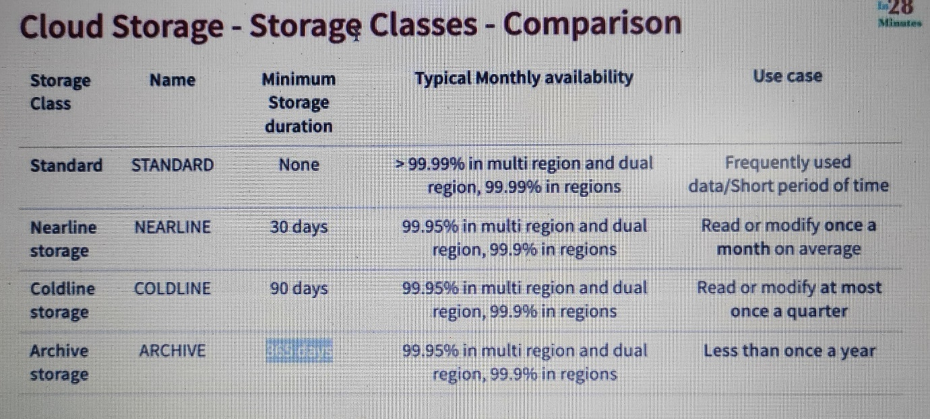

Features that are common across storage classes:

Low latency

High durability (99.999999999 –> 11-9’s)

Same api for all storage classes

Committed SLA is 99.95 for multi region and 99.9 for single region for standard, nearline, coldline storage classes

No SLA for archive

Unlimited storage

Autoscaling

No **minimum** object size

Object life cycle management:

Files are frequently accessed when they are created

Generally usage reduces with time

How do you save costs by moving files automatically between storage classes?

Solution: object lifecycle management

Identify objects based on conditions

Age, createdbefore, islive, matchesstorageclass, Numberofnewerversions etc

Can set multiple conditions

Ex: if the obect age is > 1 year and numberofnewerversion >10

Two kinds of actions (it makes sense to archive the objects i.e., to change the storage class to another or to delete)

SetStorageClass actions (change from one storage class to another)

Deletion actions (delete objects)

Allowed Transitions:

(Standard or Multi-regional or regional) to (Nearline or coldline or Archive)

Nearline to (coldline or Archive)

Coldline to Archive

You can add rules by going in to bucket and “add object lifecycle rule”

Basic important information:

Standard cloud storage class is recommended for frequently used data

Coldline cloud storage class is recommended for data that is expected to access once in a quarter

Archive cloud storage class is expected to store data that is expected to access once in a year

Object versioning is used to avoid accidental deletion of files

Object lifecycle management helps in optimize costs by automatically move data between different storage classes

Cloud Storage – Encryption:

Cloud storage always encrypts on server side

Configure server side encryption – encryption performed by cloud storage

1: google managed encryption key

2: customer managed encryption keys- created using cloud key management services KMS

(Optional) client-side encryption – encryption performed by customer before upload

## Big Query:

A fully managed serverless, highly scalable, and cost effective cloud datawarehouse designed for business agility

Datawarehouse for analytics which can store exabytes of data

Has built-in query engine which can run SQL queries on terabytes of data in seconds and petabytes of data in minutes

### How does it solve traditional data warehousing problems:

Provides high streaming insertion API

Capacity to read 1000 rows per second

Tb of batch data per second

Supports AI and ML:

Applies ML to data with BigQuery ML (which is machine learning in simple SQL)

Integration with AI platform prediction and tensorflow (enables you to train powerful models on training data with SQL)

Fully managed:

Eliminates maintenance, versioning, securing (google does provisioning behind the scenes)

We can just focus on data and analysis

Scalable (scans terabytes in seconds and petabytes in minutes)

Pay as You Go pricing

Pay separately for computing and storing

Supports caching mechanism, don’t need to pay extra if you run the same query as results of previous execution are cached

Automated data transfer

Fully managed data transfer mechanisms

Can easily import data from amazon S3, Teradata to BigQuery

You can make read only shared datasets that internal and external users can query and share results to any users through google sheets, looker, tableau or google data studio.

Access Control:

Uses IAM (Identity Access Management) to control access service for different set of users

Assign read-write, running jobs, etc, permissions in project

### Some other out of the box features:

BigQuery GIS (Geographical information system)

Obtains insights from geographical data points

Auto Backup:

Automatically backs up data and keeps a history of last 7 days changes

Makes it easy to compare data from different stores

Integration with other GCP services:

Easy integration using Dataproc (can be used to connect to Hadoop/spark cluster), BigQuery

Foundation for BI:

Backbone for modern BI solutions

Seamless data transformation, integration, analysis, visualization and reporting

Programmatic Interaction:

BigQuery provides a REST API for easy programmatic access and application integration.

Client libraries are available in Java, Python, Node.js, C#, Go, Ruby, and PHP. Business users can use Google Apps Script to access BigQuery from Sheets.

Security :

Your data is secured at the highest level of security.

Data in Bigquery is always encrypted at rest and in transit. (data is not just stored directly, data is partitioned in to smaller **data blocks** and each **data blocks** is encrypted with different security key, which makes it impossible to steal data)

Rich monitoring logging and alerting through cloud audit logs

Federated queries: process external data sources (**data which is not in cloud**) in objects (parquet, ORC, open source file formats), also can process transactional databases (Bigtable, cloud SQL or spreadsheets in drive)

Run data science workloads

Powerful data repositories: more than 100 high demand public datasets from different repositories

Accessing BigQuery can be done through webUI and also through cli and also through various client libraries

Region vs multi region: region is a geographic location, ex: Canada, multiregion is a set of regions, ex: EU, USA . we need to choose region or multiregion carefully, as it denotes where your target users who use services reside, if your application is catering all people in US, you might want to use US as choice, if your application caters specific people in Mumbai, then use Mumbai as your choice

If you know, failures are broadly classified into 2 types – Soft failures and hard failures.

Soft failure is an operational deficiency where the hardware is not destroyed.

Examples include power failure, network partition, or a machine crash.

However Hard failure is an operational deficiency where the hardware gets destroyed.

Hard failures are more severe than soft failures.

Examples include damage from floods, earthquakes, and hurricanes etc.

Having said that, guys, in a single region, data is stored only in that region.

There is no Google Cloud–provided backup or replication to another region.

It does not mean that your data is not backed up at all.

There are replicated copies of your data but it will be in the same regional datacenters

where you have defined your dataset.

Owing to these facts it can be deduced that a regional dataset is resilient to soft failures

but not to hard failures.

You may loose your data if the whole region got hit by some disaster.

So If you want resilience in the region, you yourselves need to create cross-region dataset

copies to enhance your disaster recovery guarantees but that obviously comes at its own cost.

On the other hand, In a multi-region, data is stored in a single region but is backed

up in geographically-separated regions to provide resilience to a regional disaster.

If you have multi-region copies of your data then it is resilient to both soft and hard

failures.

In event of any machine-level failure, BigQuery will continue running with no more than a

few milliseconds delay.

Also You don’t have do this backup yourself and the recovery and failover process is fully

managed by Google BigQuery Bigquery can directly query the data which is present in Cloud Storage, big table, google drive etc without physically ingesting it.

In that case, the data you're querying must be in the same location as your BigQuery dataset.

For example, if your Cloud Storage bucket containing the data is in the EU multi-region,

then the Bigquery dataset must be in a EU multi-region and Same applies to the regions as well. So that’s for the regions and multi-region, now you can wisely choose a region or multi-region.

Location assigned to dataset can not be reassigned, you may have to copy or create manually

Quotas and limits per datasets

Can have unlimited datasets, but more than 1000 datasets will degrade dashboard performance

Unlimited tables per dataset, but more than 50,000 tables will slowdown enumeration

2500 authorized views to a dataset’s control list

### Google cloud home page or dashboard:

**Project info tab:** lists project information,

while creating a project you can also give organization name, and organization name has one level above the projects and one organization can have any number of peojects under it, you can add people to project provided that you have appropriate access

API section of project index or home page shows the network traffic of that page (fire any query and you can see spike in the graph)

Resources tab shows list of resources being used in the current project

Google cloud platform status – provides information on the services that are being offered at google cloud platform

Cards in dashboard are customizable, to add cards click on customize and add them

### Partitioning:

Dividing large table based on some critical columns, based on which more filtering is done.

Uses:

Cost effective

Time effective

Parallelism

Individual partitions are managed independently

Different partitions can be stored on different sub systems (information which is needed fastly can be stored on faster disks)

Helpful while doing upserts on bulk table (a common practice in data warehousing)

Can do partition by ingestion time (with day intervals), date or timestamp, integer column

### Bq commands:

Bq show – lists projects

To display information about data set (use --dataset flag)

Syntax: bq show --dataset <project name>:<dataset name>

Ex: bq show --dataset tiger-mle:tempdataset

To see schema of a table (use --schema flag)

Syntax: bq show --schema <project name>:<dataset name>.<table name>

Ex: bq show --schema tiger-mle:tempdataset.demo_part_int

**If you don’t want to use bq every time in the command and want to start interactive mode where you can run bq commands without using bq in it- bq shell**

To exit from interactive shell type **exit**

If project id and dataset are default values, in the above syntaxes you can omit project and dataset information, if either of them is only set you can avoid values which are set

For example if your project is already having default value tiger-mle

To get schema of a table inside it you can use dataset name and table name

Ex: bq show --schema tempdataset.demo_part_int

Flags are of 2 types:

Global flags- flags that can be used with any command , few imp global flags below, for all global flags refer (https://cloud.google.com/bigquery/docs/reference/bq-cli-reference#bq_global_flags)

--location: choose which location where to run the command

--format: specifies the format of the command output

pretty -> formatted table output

sparse -> simpler table output

prettyjson -> human readable json

json -> compact json

csv -> csv format with header

pretty, sparse, prettyjson for human readable, json,csv are to pass as input to other commands

--job-id -> to set job id explicitly to have easy recall

Cancel- used to cancel jobs

Bq cancel <job-id>

Ex query using flags- bq show --schema --format prettyjson <dataset>.<table name>

Command specific flags: commands that can be used with only particular command

While using flags, global flags come first and then command specific flags

Syntax is as below

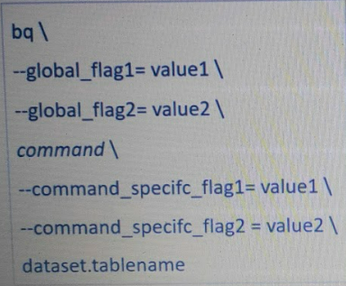

Assignments can be different as well

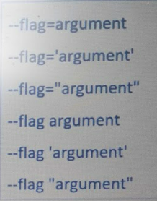

BQ queries to query SQL commands (detail link- <https://cloud.google.com/bigquery/docs/reference/bq-cli-reference#bq_query>):

bq query --use_legacy_sql=false 'SELECT * FROM `<project name>`.<dataset name>.<table name>

if you just want the correctness of the query and bytes processd use --dry_run option

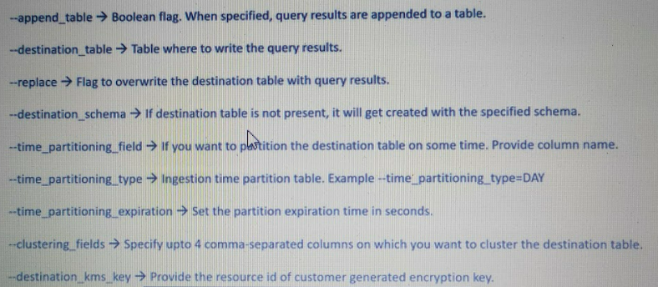

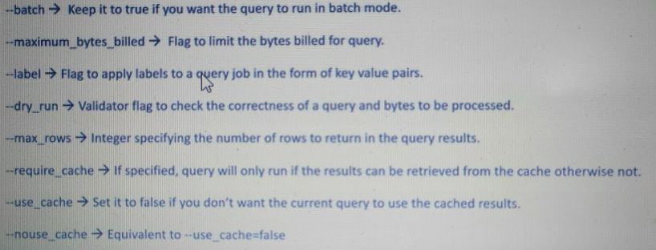

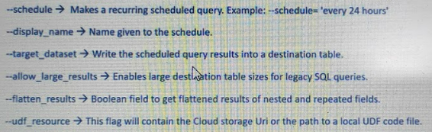

There are few operations which are not possible with cloud console, and are possible with bq cli

1. Relaxing column mode to nullable
2. Copying selected partitions of the table

### Misc:

For ML engineers once the data is in Bigquery you can call it from your IPython ML notebooks

the key aspect to see from this BigQuery architecture is that storage and compute are decoupled from each other, and they scale independently on-demand. This offers immense flexibility and cost control to business

**Service account** is like a connection and authentication key to your google cloud account (that means you can a).

## Handson learnings:

* gcloud auth login-> when you don’t have access to browser(for ex in vs code) while running this command, the response command should be typed in cmd and response of that cmd should be opened in browser and should be provided authentication, then there should be a response in cmd that command is to be copied to vs code and if successful, will give you your mail and project details if any
* While doing **gcloud auth login,** it is always better to start all process by reloading the window and execute all cells once again, if there is a change (the change can be as small as changing the change in value for (service account) key- “GOOGLE_APPLICATION_CREDENTIALS” )
* Client library – suppose there is a service called bigquery which will deal with DDL and DML operations for vast amounts of data, but people who are familiar with python can not use it all of a sudden because they are not well versed with it, client library comes to help in such cases, where we can use **python client library for bigquery** which can help do some works in python as well, therefore **embedding** some parts of sql inside it , but finally the file will be a python file
* **Cloud SDK** is a set of Tools and libraries for interacting with Google Cloud products and services.Basically it is a kind of local interface to access google cloud which mimics the cloud shell that we have here locally to your system.You just have to download the package, install it ..there will be a 1 time connectivity with your credentials and you are good to go
* bigquery.Client is used to query sql scripts to bigquery and get google.cloud.bigquery.job.query.QueryJob in return
* types of bigquery magic functions-
* syntax
* %%bigquery <option> {value}
* %%bigquery --project {PROJECT} #this magic function will just take project value so that it can run query
* SELECT ML_use, COUNT(*)
* FROM playground_us.chicago_taxitrips_prep # Change to your BQ dataset and table names.
* GROUP BY ML_use
* #the output will be a table
* Type 2
* syntax
* %%bigquery <variable where the query result will be stored as df> <option> {value for option}
* %%bigquery sample_data --project {PROJECT}
* SELECT * EXCEPT (trip_start_timestamp, ML_use)
* FROM playground_us.chicago_taxitrips_prep # Change to your BQ dataset and table names.
* When you get default credential errors, you need to set env variable with service account generated key, to solve error
* import os
* os.environ['GOOGLE_APPLICATION_CREDENTIALS'] = '/home/saivinil_pratap/mlops-with-vertex-ai-v2/key-by-dinesh-tiger-mle-e5a6296c4fb4.json'
* os.environ['GOOGLE_APPLICATION_CREDENTIALS']
* vertex ai has:
  + model.list (to work on models )
  + tensorboard.create (to create tensorboard for experiments)
  + init() (to initialize experiments)
  + start_run() (to run experiments)
  + log_params
  + log_metrics
  + explain.explanation_metadata
  + explain.explanation_parameters
  + model.upload()
  + get_experiment_df() (to extract run parameters)
  + custom_job
  + HyperparameterTuningJob
* Cloud Build is a service that executes your builds on Google Cloud.
  + Cloud Build can import source code from a variety of repositories or cloud storage spaces, execute a build to your specifications, and produce artifacts such as Docker containers or Java archives.
* Pipeline_root is a google cloud storage bucket,
* AIPlatformClient is used to schedule pipelines, aiplatform from vertexai can also used

changes for code:

max_tokens is changed to num_tokens in src.modeltraining.model.py

# AWS:

## About AWS:

* AWS stands for amazon web services
* They provide you with servers and services that you can use **on-demand** and **scale** easily
  + Ex: Netflix does not own a single server, they use aws, which allows them to run at **scale**

## IAM- Identity and Access Management:

* It is a global service, i.e., it does not require a region to be selected for IAM. IAM provides fine-grained access control across all of AWS
* With IAM you can control access to services and resources under specific conditions
* Use IAM policies to manage permissions to your workforce and ensure least **privilege i.e.,** don’t give user permissons more than what they need
* Offered at no additional charge
* IAM is used to create root account- which has unrestricted access to all resources (can do pretty much anything) including billing information, so root account should not be **shared** or **used**
* Root should be used to create administrator account, which can do pretty almost everything a root user can do. It is best practice that a root user should only be used to create administrator account and never be touched again unless it is really really a need to do so.
* Users can be grouped
* All users who are developers can be made in to one group, similarly Ops people can be made in to one group.
* Groups only contain users, groups cannot have other groups
* Like whatsapp, a user can be single or be part of one or multiple groups
* Groups are useful when you want to provide similar permissions to a set of people because of some reason.
* Users and groups are assigned **JSON documents** called **policies**, these policies **define permissions of users**
* Any user placed in a group will inherit the permissions associated with the group
* We can login to aws as a **root user** or an **IAM user (an IAM** user can be a administrator or a normal user based on the permissions he is given**)**
* As we already know a root user can create normal users or administrator, but for them to sign in root user need to create a url, which can be obtained by creating an alias for account using **account alias** which will be available in the IAM dashboard **(will be same for everyone in the account)** then you can have a signin url through which users or administrators or an IAM user can login as an IAM user
* **inline policy**: an IAM policy which is embedded in an identity (user, group or a role), i.e., an inherent part of an Identity (a inline policy is something, that is created for a particular role and cannot be used for other roles)

### IAM policy structure:

The IAM policy structure will be a json file and looks something like this

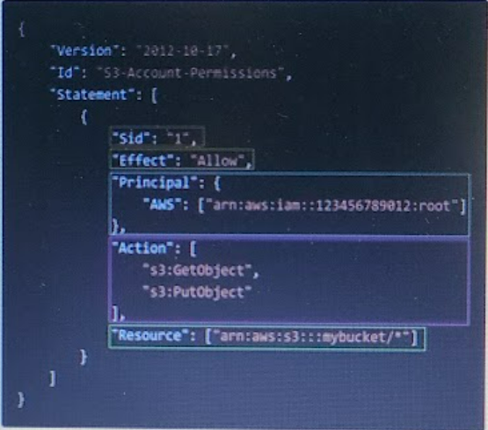

* Consists of
  + Version – policy language version
  + Id – an identifier for the policy - **optional**
  + Statement – one or more individual statements
    - Sid- statement Identifier – **optional**
    - Effect – wether this statement is allowing or denying access, values accepted- allow, deny
    - Principal – account/user/role to which this policy is applied to.
      * Whenever there is principal in policy it's applied to a service (like S3) and not to an IAM user.
      * IAM user policies don't have a principal because it is applied to a user/group.
    - Action - list of actions this policy allows or denies (allowing or denying will be based on **Effect** parameter above)
    - Resource – list of resources to which the **action**s is applied to
    - Conditions: conditions for when this policy is in effect – **optional**
  + Let us take the example of above policy in the above recent image- it is applicable to root user who have permissions of get object and put object for a bucket named my bucket (afaik)
* 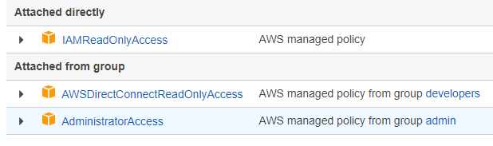
* Here we are viewing policies of a user, he had one policy attached **directly** (a policy that user got assigned directly not because of any group ), **attached from group**  these are the policies that he got because he is part of the group **developers** and **admin** apparent from the image
* The policy section in **IAM dashboard** is quite interactive, it can show the list of policies and their json structure, allows you to create custom json files as well
* MFA is a must to avoid our accounts from being compromised
  + MFA= password you know + code that your security device generates
  + MFA can be an app like google **authenticator** amazon **authy**  or some **physical device** which might be one of the various 3pd physical devices provided out there
* You can generate policies using the visual editor in the create policy section, or here as well (<https://awspolicygen.s3.amazonaws.com/policygen.html>), in policy section we also have other useful information such as who is ucing it and the version of the current update policy as well

### IAM Roles for Services:

* Roles will help in performing actions on our behalf
* They are just like users but not intended for physical people
* **Roles will be used by AWS services (this might be bit confusing, but the below example will make sense)**
  + We have EC2 (a virtual server in AWS) instance which need an access to a specific service in AWS, as you know to access a service, you need permissions, so we will assign an IAM role to EC2 instance, so that **based on the conditions mentioned in the** role it can access particular AWS services
* As you did for EC2, you can create a role for almost every service in AWS
* You can also attach policies to existing roles
* To test whether the polices that are assigned to a role are working in the expected way or not, we can use 2 ways:
  + Aws policy simulator: [IAM Policy Simulator (amazon.com)](https://policysim.aws.amazon.com/home/index.jsp)
  + Using aws CLI

### IAM security tools:

* IAM credential report (**Account level**):
  + Account level report means it will be generated for all users in common
  + A report that Lists all your account users and **status** of their various credentials
* IAM Access Advisor (**user level**):
  + User level means, if we want to see IAM access advisor, it will differ from user to user
  + Shows permissions that are granted to a user and when they were last accessed
  + This helps in revising permissions if the user is not in the need of them or if he/she is not allowed the permissions now

### IAM guidelines and best practices:

* Use the root account only for aws account setup
* One user account should only be used by one user, should not be shared among users
* Assign users to groups and permissions to groups
* Create strong password and ensure MFA usage for higher security
* Create and use roles for **giving permissions** to AWS services
* Access key is used to enable programmatic access (SDK/CLI) and access key should never be shared
* Audit permissions using IAM credentials report

### IAM Section – Summary

* Users: mapped to a physical user, has a password for AWS Console
* Groups: contains users only
* Policies: JSON document that outlines permissions for users or groups
* Roles: for EC2 instances or AWS services
* Security: MFA + Password Policy
* Access Keys: access AWS using the CLI or SDK
* Audit: IAM Credential Reports & IAM Access Advisor

## How to Access AWS:

AWS can be accessed in 3 ways:

* AWS management console (through browser)- need password and MFA
* AWS CLI – protected by Access keys

Using CLI, you can

* + Have direct access to API of aws
  + Can develop scripts to manage resources
  + Use this as alternative to Management console
* AWS SDK to code – protected by Access keys
  + Can use SDK When you want to perform actions on AWS without using CLI
  + We have to use AWS SDK when you have to use AWS services such as DynamoDB
  + enables you to access aws services through programming language
  + have language specific APIs as below
    - SDK’s – javascript, python, java, PHP, .NET, RUBY…
    - Mobile SDK’s – Android, IOS …
    - IOT SDK’s – Embedded C, Aurdino
  + AWS CLI is built on AWS SDK for python named Boto
  + Good to know: if you don’t specify or configure a default region, then us-east-1 will be chosen by default

**Access keys** are generated through AWS console.

Access id is similar to username and accesskey is similar to password, so

* Users can manage their own keys
* They differ from user to user
* Should not be shared between users

To configure aws cli use command **aws configure** in cli**,** then give access id, password, region (preferably give your nearest region) and other basic details it might ask

#checkpoint

**AWS cloud shell**:

* basically a terminal in the cloud of AWS web management console
* files worked or created in cloud shell will stay, i.e., you have a working repository inside of cloud shell (upto 1gb afaik), these files will stay to other cloud shell sessions, even if you terminate the session in which you created the file.
* The **actions** option in the cloud shell:
  + will let you upload/ download files to the working space/repository
  + You can also have more than one session at a time, if needed

## EC2:

* EC2 is One of the most popular amazon offering
* EC2 = Elastic Cloud Compute = Infrastructure as a Service
* Are bound to Availability zones
* Its main capabilities are
  + Renting virtual machines (EC2)
  + Storing data on virtual **drives** (EBS- Elastic Block Store)
  + Distributing load across machines (ELB- Elastic Load Balancer)
  + Scaling the services using an ASG – Auto Scaling Group
* Knowing EC2 is a fundamental to understand how the cloud works

### EC2 sizing and Configuration options:

This means what are the features and configurations that you would like to have in the EC that you will be using

* Operating System: Linux, Windows, Mac OS
* How much compute power and Cores (CPU)
* How much Random Access memory RAM
* How much storage space
  + Network attached – (EBS&EFS – Elastic File System)
  + Hardware – EC2 instance store
* Network card (which connects computer to another computer or Network) : speed of the card, Public IP address
* Firewall rules: security group (where a rule are defined using a set of policies which inform what user have what access)
* Bootstrap script (configured at first launch) : EC2 user data

### EC2 userdata:

It is possible to launch a set of commands when you are trying to launch an EC2 instance, it is possible through **EC2 User Data script.**

* Launching set of commands along with instance is called **bootstrapping**, done through user data script
* The script is run only at the instance of the first start
* EC2 User data is used to automate boot tasks such as
  + Installing updates
  + Installing softwares
  + Downloading some files from the internet
* **The EC2 user data script runs through root user, i.e., while running the script it will have the permissions of the root user**

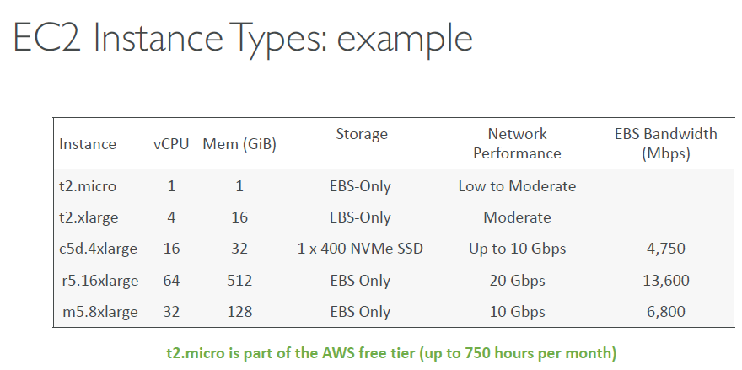

**vCPU** means the number of cores

* When you are restarting an stopped instance, the public ipv4 address will be changed, the private ipv4 will not get changed

1. In cloud computing, If you are launching an instance or 100 instances it is the same **few clicks** that will be needed to set up a virtual server
2. In cloud computing, You can just terminate a server and never use it again provided that you don’t have the use with it
3. Now imagine the points 1 and 2 above, with normal on premise physical server, imagine the time taken to setup 100 servers, or imagine the time taken to sell the servers that you don’t use, and more importantly, imagine that you will not have to pay for server usage if you are not using them in cloud computing

### Ec2 instances type overview:

* **so far** there are 7 ( to remember imagine in EC2, the 2 resembles 7 shape) types of EC2 instances and they are as follows (link might change in future- https://aws.amazon.com/ec2/instance-types/ )
  + General purpose
  + compute optimized
  + memory optimized (**RAM**)
  + storage optimized
  + accelerated computing
  + instance features
  + measuring instance performance
* EC2 has the following naming convention- <instance class>.<generation (improves over time)>.<size within the instance class>
  + Ex: m5.2xlarger

#### general purpose:

• Great for a diversity of workloads such as web servers or code repositories

• Balance between:

1. Compute
2. Memory
3. Networking

• ex: t2.micro which is a General Purpose EC2

#### Compute optimized:

Great for compute-intensive tasks that require high performance, Compute Optimized instances are ideal for compute bound **applications that benefit from high performance processors**, these instance names start with **C** ex: C7g, C6g and ….

processors:

• Batch processing workloads

• Media transcoding

• High performance web servers

• High performance computing (HPC)

• Scientific modeling & machine learning

• Dedicated gaming servers

#### Memory optimized:

* Fast performance (RAM) for workloads that process **large data sets** **in memory**, **most of the** memory optimized instances start with R, as R stands for RAM.

• Use cases:

• High performance, relational/non-relational databases

• Distributed web scale cache stores

• In-memory databases optimized for BI (business intelligence)

• Applications performing real-time processing of big unstructured data

#### Storage Optimized

• Great for storage-intensive tasks that require high, **sequential read and write**

**access to large data sets on local storage,** names might start with I,D,H

• Use cases:

• High frequency online transaction processing (OLTP) systems

• Relational & NoSQL databases

• Cache for in-memory databases (for example, Redis)

• Data warehousing applications

• Distributed file systems

#### EC2 instance Metadata:

• AWS EC2 Instance Metadata is ***powerful but one of the least known features to developers***

• It allows AWS EC2 instances to “***learn about themselves***” without using an IAM Role for that purpose.

• The URL is <http://169.254.169.254/latest/meta-data>, this IP is basically internal IP to AWS, it will not work from our computers

• You can retrieve the IAM Role name from the metadata, but you CANNOT retrieve the IAM Policy.

• Metadata = **Info about the EC2 instance**

• Userdata = **launch script of the EC2 instance**

**When you connect to an EC2 instance using “Ec2 instance connect” option and run the following commands:**

* curl htts://169.254.169.254/ - gives version of curl api
* curl htts://169.254.169.254/latest/ - gives metadata and userdata i.e., **these curl commands can access metadata without an IAM role.** will have directories which have furthermore data, metadata has various information about EC2 instance which is in connection
* curl <http://169.254.169.254/latest/meta-data/> - gives metadata about EC2 instance
* curl <http://169.254.169.254/latest/meta-data/instance-id> - gives instance id details
* curl [http://169.254.169.254/latest/meta-data/local-ipv4 - gives ipv4](http://169.254.169.254/latest/meta-data/local-ipv4%20-%20gives%20ipv4) details
* curl <http://169.254.169.254/latest/meta-data/>iam/security-credentials - gives roles related to that instance
* curl [http://169.254.169.254/latest/meta-data/iam/security-credentials/<rolename](http://169.254.169.254/latest/meta-data/iam/security-credentials/%3crolename)> this gives access key id, secret access key and few other details, **this is the way for an ec2 instance to performs api calls is to query this whole url, which gets it a secret access key, token and access ID (which are short lived and temporary), this way EC2 instance gets its temporary credentials through the IAM role, that it got attached to it**

### Introduction to Security groups:

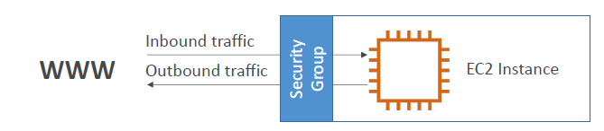

* Security groups are the fundamental of network security in AWS
* They control how traffic is **allowed into or out** of EC2 instance
* Security groups contain only allow rules
* Security rules can reference by IP or by **security group (will be explained in one of the upcoming image )**

#### Security groups, deeper dive:

Security groups are acting as a “firewall” on EC2 instances

They regulate:

• Access to Ports

• Authorised IP ranges – IPv4 and IPv6

• Control of inbound network (from other to the instance)

• Control of outbound network (from the instance to other)

Port- from where the traffic can go through

Source: Ip address range,

0.0.0.0/0 means from source anywhere on IPV4 format

::/0 -> means from source anywhere on IPV6 format

Source value will be populated for both inbound rule and outbound rule

Inbound source: 0.0.0.0/0

Outbound source:0.0.0.0/0 means we have everything allowed on all ports from anywhere to anywhere

Also inbound rule and outbound rule traffic passing depends upon Protocol, Port range and source



#### Good to know points about Security groups:

* One security group can be attached to multiple instances and vice a versa
* Locked down to a region/VPC (Virtual Private Cloud) combination, i.e., you have to create a new security group incase if you shift the region, or if you create another VPC
* Similar to Firewall, a security group lives outside the instance, if some traffic is blocked by security group, then EC2 will not even have a idea about that traffic
* It is good to maintain separate security group for SSH access, it is most complicated and you should be taking care that everything is done correctly.

• If your application is not accessible (time out), then it’s a security group issue

• If your application gives a “connection refused“error, then it’s an application error or it’s not launched

• All **inbound** traffic is **blocked** by default

• All **outbound** traffic is **authorised** by default

* If you get a timeout error while connecting to an EC2 instance, this means there is some **security group issue** with the **security group rules (most probably inbound rule) related to that EC2 instance**
* the inbound and outbound rules **can be edited later after the instance is created as well**
* while creating/editing inbound rule you can have various options for source , if you choose **custom**-> you can add already **existing security group** for inbound rule, which very well explains the below image, or you can select **my IP** for source option, so that the instance will only allow inbound traffic from this computer

##### One security group referring other security group rules

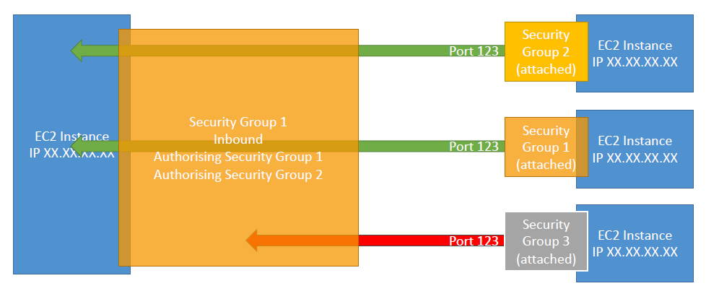

Here the first 2 ec2 instances on the right hand side are accepted as inbound traffic, security group 2 inbound traffic is allowed (to the EC2 instance on the left side) because, the inbound rule is authorising security group 2 by default, similarly another ec2 instance on the right hand side is allowed

### Classic ports to Know

• 22 = SSH (Secure Shell) - log into a Linux instance

• 21 = FTP (File Transfer Protocol) – upload files into a file share

• 22 = SFTP (Secure File Transfer Protocol) – upload files using SSH

• 80 = HTTP – access unsecured websites

• 443 = HTTPS – access secured websites

• 3389 = RDP (Remote Desktop Protocol) – log into a Windows instance

### Ways to connect to EC2 instance:

#### Through SSH:

To connect inside of the servers for some maintenance activity inside, you can use SSH

We can SSH in to EC2 instance, using commands, and we also remember that security group allows anyone to connect to it as it accepts anyone through source (ssh-port 22- 0.0.0.0/0), but it is risky for anyone to have access, and that is why we have key with us so that we can make sure, we only access that EC2 and no one else.

Command (to connect through linux or mac) : ssh -i <key that you downloaded when you generated instance afaik> ec2-user@<public IPV4 address>

Incase if you get error:

* In linux or mac

- change permissions of the key to 0400

Ex: chmod 0400 <path of the key>

* In windows you have to go to the properties of file->security->advanced->

Then try again to run the above ssh command

#### Using EC2 instance connect:

EC2 instance connect option is available in the instance section of EC2 in aws web management console, **ec2 instance may only work with amazon x2 or ubuntu so far,** I mean it might not work with every EC2 instance

What happens here is, you have to **select the instance** and then click on instance **connect ,** then aws will shift to new window, then give username of your instance if prompted, then click on connect, it will open a new window, where you can see an ssh running, this SSH relies on the ssh connection information we give in the **security group** section of EC2, if you delete ssh **security group rule** in the **inbound rules section** then you will not be able to connect to ec2 instance using ec2 instance connect option, to connect back again, you need to add that **security group rule** in the **inbound rule** section

When you connect to EC2 instance using **ec2 instance connect** it will have cli for AWS already installed, that means you can run AWS related commands directly to make all the changes you want in EC2 instance with the help of the commands.

In general when you are connecting through CLI you need to use your access keys to configure your aws cli,

in literal terms a virtual SSH (using EC2 instance connect), which supports CLI, it is not a good idea to use access keys, instead we will use IAM roles, we create an role – IAMReadOnlyAccess in IAM and then assign it to instance by , selecting instance->clicking on actions->clicking on security->add IAM role.

Reason:

IAM role on EC2 will help us to give access to AWS services without configuring long term AWS credentials (access/secret key), we should not be giving access/secret key because if we give anyone with access to ssh can retrieve them

It is important to use IAM roles for EC2 instances

### EC2 instance purchasing options: (lengthy read only if needed, else look at analogy in the last)

• On-Demand Instances – short workload, predictable pricing, pay by second

• Reserved (1 & 3 years)

• Reserved Instances – long workloads

• Convertible Reserved Instances – long workloads with flexible instances

• Savings Plans (1 & 3 years) –commitment to an amount of usage, long workload

• Spot Instances – short workloads, cheap, can lose instances (less reliable)

• Dedicated Hosts – book an entire physical server, control instance placement

• Dedicated Instances – no other customers will share your hardware

• Capacity Reservations – reserve capacity in a specific AZ for any duration

**Points to consider: dedicated instances and dedicated hosts have many differences**

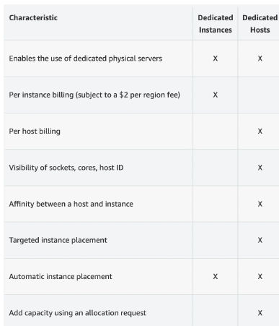

#### EC2 On Demand

• Pay for what you use:

• Linux or Windows - billing per second, after the first minute

• All other operating systems - billing per hour

• Has the highest cost but no upfront payment

• No long-term commitment

• Recommended for short-term and un-interrupted workloads, where

you can't predict how the application will behave

#### EC2 Reserved Instances

• Up to 72% discount compared to On-demand

• You reserve a specific instance attributes (Instance Type, Region, Tenancy, OS)

• Reservation Period – 1 year (+discount) or 3 years (+++discount)

• Payment Options – No Upfront (+), Partial Upfront (++), All Upfront (+++)

• Reserved Instance’s Scope – Regional or Zonal (reserve capacity in an AZ)

• Recommended for steady-state usage applications (think database)

• You can buy and sell in the Reserved Instance Marketplace

• Convertible Reserved Instance

• Can change the EC2 instance

#### EC2 Savings Plans

• Get a discount based on long-term usage (up to 72% - same as RIs)

• Commit to a certain type of usage ($10/hour for 1 or 3 years)

• Usage beyond EC2 Savings Plans is billed at the On-Demand price

• Locked to a specific instance family & AWS region (e.g., M5 in us-east-1)

• Flexible across:

• Instance Size (e.g., m5.xlarge, m5.2xlarge)

• OS (e.g., Linux, Windows)

• Tenancy (Host, Dedicated, Default)

#### EC2 Spot Instances

• Can get a discount of up to 90% compared to On-demand

• Instances that you can “lose” at any point of time if your max price is less than the

current spot price

• The MOST cost-efficient instances in AWS

• Useful for workloads that are resilient to failure

• Batch jobs

• Data analysis

• Image processing

• Any distributed workloads

• Workloads with a flexible start and end time

• Not suitable for critical jobs or databases

#### EC2 Dedicated Hosts

• A physical server with EC2 instance capacity fully dedicated to your use

• Allows you address compliance requirements and use your existing serverbound

software licenses (per-socket, per-core, pe—VM software licenses)

• Purchasing Options:

• On-demand – pay per second for active Dedicated Host

• Reserved - 1 or 3 years (No Upfront, Partial Upfront, All Upfront)

• The most expensive option

• Useful for software that have complicated licensing model (BYOL – Bring Your

Own License)

• Or for companies that have strong regulatory or compliance needs

#### EC2 Dedicated Instances

Instances run on hardware that’s

dedicated to you

• May share hardware with other

instances in same account

• No control over instance placement

(can move hardware after Stop / Start)

#### EC2 Capacity Reservations

• Reserve On-Demand instances capacity in a specific AZ for any duration

• You always have access to EC2 capacity when you need it

• No time commitment (create/cancel anytime), no billing discounts

• Combine with Regional Reserved Instances and Savings Plans to benefit

from billing discounts

• You’re charged at On-Demand rate whether you run instances or not

• Suitable for short-term, uninterrupted workloads that needs to be in a

specific AZ

#### Analogy to select best purchasing option

Let us think you are going to stay in a hotel, choosing a right room is as same as choosing an ec2 instance purchasing option, read below

• On demand: coming and staying in resort

whenever we like, we pay the full price

• Reserved: like planning ahead and if we plan to

stay for a long time, we may get a good discount.

• Savings Plans: pay a certain amount per hour for

certain period and stay in any room type (e.g.,

King, Suite, Sea View, …)

• Spot instances: the hotel allows people to bid for

the empty rooms and the highest bidder keeps the

rooms. You can get kicked out at any time

• Dedicated Hosts: We book an entire building of

the resort

• Capacity Reservations: you book a room for a

period with full price even you don’t stay in it

#### price comparison example for specific instance

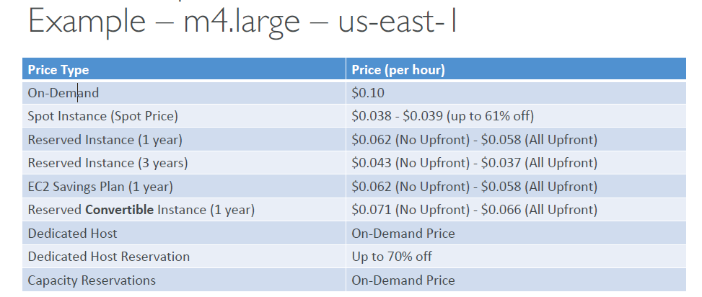

#### Deep dive in to spot instances:

• Can get a discount of up to 90% compared to On-demand

• Define max spot price and get the instance while current spot price < max

• The hourly spot price varies based on offer and capacity

• If the current spot price > your max price you can choose to stop or terminate your

instance with a 2 minutes grace period.

• Other strategy: Spot Block

• “block” spot instance during a specified time frame (1 to 6 hours) without interruptions

• In rare situations, the instance may be reclaimed

• Used for batch jobs, data analysis, or workloads that are resilient to failures.

• Not great for critical jobs or databases

##### When a spot instance go away:

You can only cancel Spot Instance requests that are open, active, or disabled.

Cancelling a Spot Request does not terminate instances

You must first cancel a Spot Request, and then terminate the associated Spot Instances

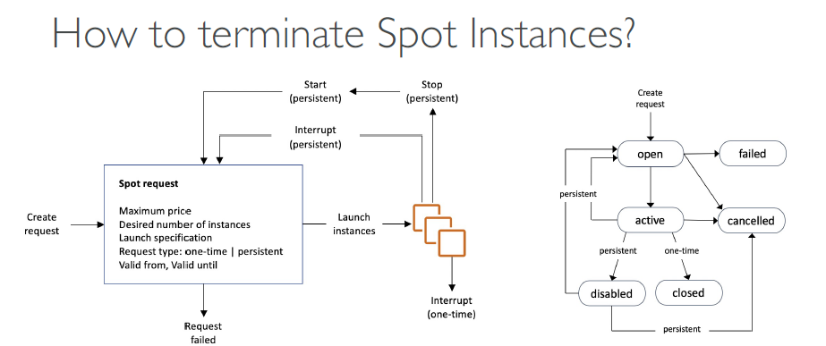

**Difference between onetime and persistent request:**

Let's have a look at the difference.,

If it's a one-time request,

as soon as your spot request is fulfilled,

your instances are going to be launched.,

And then your spot request will go away,

because it was a one-time request type.,

So in this case, your spot request is going to go away,

and you're fine.,

But if it's a persistent request type,

that means that we want this number of instances to be valid,

as long as the spot request is valid from to valid until.,

That means that if somehow your instances do get stopped,

or interrupted based on the spot price,

then your spot requests will go back into action.,

When things can be validated,

we'll restart spot instances for you.,

So if somehow you stop a spot instance, in persistent mode,

and your spot request is still active,

your spot request automatically will be smart enough,

to restart a launch instance for you.,

And this is something you can also see in this diagram

##### Spot fleets:

• Spot Fleets = set of Spot Instances + (optional) On-Demand Instances

• The Spot Fleet will try to meet the target capacity with price constraints

• Define possible launch pools: instance type (m5.large), OS, Availability Zone (AZ)

• Can have multiple launch pools, so that the fleet can choose

• Spot Fleet stops launching instances when reaching capacity or max cost

• Strategies to allocate Spot Instances:

• lowestPrice: from the pool with the lowest price (cost optimization, short workload)

• diversified: distributed across all pools (great for availability, long workloads)

• capacityOptimized: pool with the optimal capacity for the number of instances

• Spot Fleets allow us to automatically request Spot Instances with the lowest price

### EC2 instances summary:

EC2 Instance: AMI (OS) + Instance Size (CPU + RAM) + Storage +security groups + EC2 User Data

• Security Groups: Firewall attached to the EC2 instance

• EC2 User Data: Script launched at the first start of an instance

• SSH: start a terminal into our EC2 Instances (port 22)

• EC2 Instance Role: link to IAM roles

• Purchasing Options: On-Demand, Spot, Reserved (Standard +Convertible + Scheduled), Dedicated Host, Dedicated Instance

## Elastic Network interfaces

### Private vs Public vs Elastic

• Networking has two sorts of IPs. IPv4 and IPv6:

• IPv4: [0-255].[0-255].[0-255].[0-255].-**divided in to 4 parts separated by 3 dots** and is full of ***digits***

Ex: 1.160.10.240

• IPv6: 3ffe:1900:4545:3:200:f8ff:fe21:67cf – **divided in to 8 parts,** allows hexadecimal digits i.e., 0-9,A-F

• In this course, we will only be using IPv4.

• IPv4 is still the most common format used online.

• IPv6 is newer and solves problems for the Internet of Things (IoT).

• IPv4 allows for 3.7 billion different addresses in the public space

#### Private vs public IPV4:

• Public IP:

• Public IP means the machine can be identified on the internet (WWW)

• Must be unique across the whole web (not two machines can have the same public IP).

• Can be geo-located easily

• Private IP:

* + Private IP means the machine can only be identified on a private network only
  + The IP must be unique across the private network
  + BUT two different private networks (two companies) can have the same IPs.
  + Machines connect to WWW using a Network Address Translation (NAT)
  + Only a specified range of IPs can be used as private IP

Let us say there are 2 servers which are public and 1 company with private nework, then they servers, which are public can talk over World Wide Web, the computers within the company network can communicate directly, but to communicate with WWW, they need a **internet gateway**, which is public.

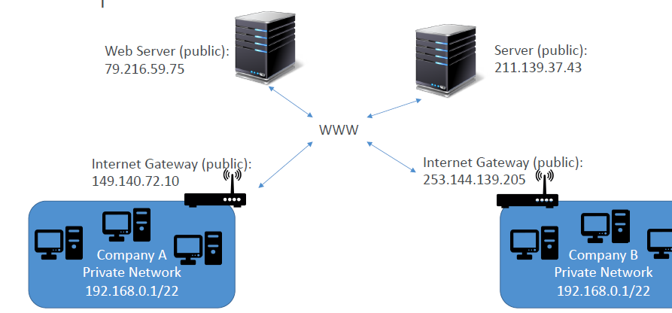

#### Elastic IP:

When you stop and then start an EC2 instance, it can change its public

IP.

• If you need to have a fixed public IP for your instance, you need an

Elastic IP

• An Elastic IP is a public IPv4 IP you own as long as you don’t delete it

• You can attach it to one instance at a time

• With an Elastic IP address, you can mask the failure of an instance or software

by rapidly remapping the address to another instance in your account.

• You can only have 5 Elastic IP in your account (you can ask AWS to increase

that).

• Overall, try to avoid using Elastic IP:

• They often reflect poor architectural decisions

• Instead, use a random public IP and register a DNS name to it

• Or, as we’ll see later, use a Load Balancer and don’t use a public IP

#### Behaviour of public and private IP in aws:

• By default, your EC2 machine comes with:

• A private IP for the internal AWS Network

• A public IP, for the WWW.

• When we are doing SSH into our EC2 machines:

• We can’t use a private IP, because we are not in the same network

• We can only use the public IP.

• If your machine is stopped and then started,the public IP can change

#### Summary of public vs private vs elastic:

|  |  |  |  |
| --- | --- | --- | --- |
| **Feature** | **Private** | **Public** | **Elastic** |
| Communication | Communication within VPC | Can communicate over internet | Can communicate over internet |
| Address range | Gets IP address from subnet range. Ex: 10.200.0.1 | Gets IP address from Amazon Pool within region | Gets IP address from Amazon Pool within region |
| Instance restart behavior | Once assigned cannot be changed | Changes over instance restart | Do not change over instance restart. Can be removed anytime. |
| Releasing IP | Released when instance is terminated | Released to POOL when instance is stopped or terminated | Not released. Remains in your account. (Billed) |
| Automatic Assignment | Receives private ip on launch on EC2 instance | Receives public ip on launch on EC2 instance if “Public ip addressing attribute” is set to true for subnet | Have to explicitly allocate and attach EIP to EC2 instance. Can be reattached to other EC2 |
| Examples | Application servers, databases | Web servers, Load Balancers, Websites | Web servers, Load Balancers, Websites |

As we know we can use private ip only inside aws, to get inside of aws, you need to use public ip and then ssh in to ec2, then you can use the private IP

When ever you are using a normal IPv4 public address to perform ssh, each time the instance is stopped and started again, the public ipv4 is changed, to avoid this change, we can use elastic IPV4 address, create an elastic Ipv4 using options and associate it to instance,

Advantages of Elastic IP:

If an instance with elastic IP fails, then you can detach the elastic IP and then attach it to the new instance you want to create in stead of the failed instance

**Drawbacks of elastic address:**

1. Elastic ip address are limited in number
2. Using elastic ip address is not considered a good practice
3. Instead elastic IP address we can use elastic load balancer
4. When you create an elastic IP and don’t use it, you will be charged

### Elastic network interfaces ENI- Overview:

It is an advanced concept in AWS.

We can create an ENI using Network interface section, or a ENI is automatically created when an EC2 instance is created, An ENI has the following components

**The main use of ENI so far is- whenever you create an ENI, a IPV4 is assigned to it, lets assume a scenario where 2 ec2 instances are serving a same application, and we have attached the newly created ENI to the first EC2 instance, and it is working fine, suppose the second instance IPV4 (which comes when we create EC2 instance) is not working, then we can detach the ENI that is attached to first ec2 instance and then attach it to the second EC2 instance to handle failover, seamlessly**

**Suppose you have an instance attached to ENI, and then delete that instance, then the instance gets deleted but the ENI, stays**

• Logical component in a VPC that represents a

virtual network card

• The ENI can have the following attributes:

• Primary private IPv4, one or more secondary IPv4

• One Elastic IP (IPv4) per private IPv4

• One Public IPv4

• One or more security groups

• A MAC address

• You can create ENI independently and attach

them on the fly (move them) on EC2 instances

for failover

• Bound to a specific availability zone (AZ)

Consider the below image

One IPV4 of an EC2 instance can be moved to another EC2 instance in case of failover

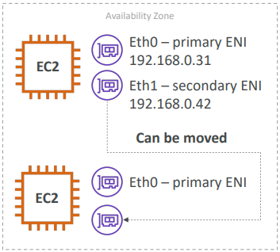

## Elastic Block Store (EBS) Volume:

An EBS (Elastic Block Store) Volume is a network drive you can attach to your instances while they run

• **It allows your instances to persist data, even after their termination**

• They can only be **mounted to one instance at a time** (at the CCP level)

• They are bound to a specific availability zone

• Analogy: Think of them as a “network USB stick” **– basically a usb stick type of data transfer that happens over Network drive, as they have specific availability zone nature discussed in previous point, you cannot attach/transfer data from computer which is in one zone-ex: us-east-1a to another zone us-east-1b**

• Free tier: 30 GB of free EBS storage of type General Purpose (SSD) or

Magnetic per month]

• It’s a network drive (i.e. not a physical drive)

• It uses the network to communicate the instance, which means there might be a bit of latency

• It can be detached from an EC2 instance and attached to another one quickly

• It’s locked to an Availability Zone (AZ)

• An EBS Volume in us-east-1a cannot be attached to us-east-1b

• To move a volume across, you first need to snapshot it

• Have a provisioned capacity (size in GBs, and IOPS)

• You get billed for all the provisioned capacity

• You can increase the capacity of the drive over time

* it is possible to create an EBS volume and leave it unattached, can be attached on demand, this makes it EBS very powerful

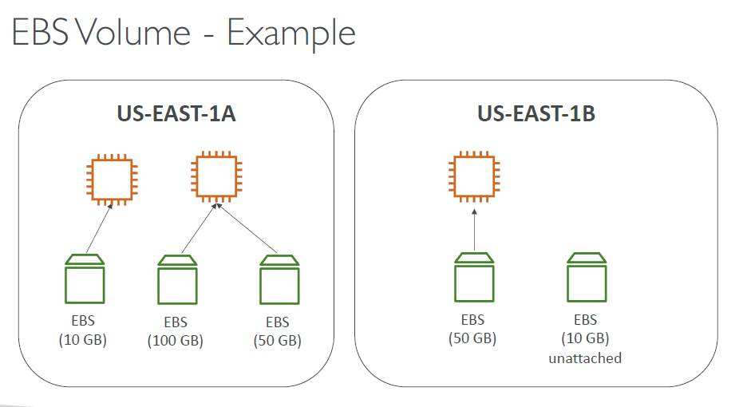

### EBS delete on termination attribute:

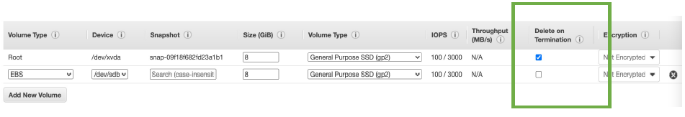

• Controls the EBS behaviour when an EC2 instance terminates

• By default, **the root** EBS volume is deleted (attribute enabled)

• By default, any other attached EBS volume is not deleted (attribute disabled)

• This can be controlled by the AWS console / AWS CLI

• Use case: preserve root volume when instance is terminated

### EBS snapshots:

• Make a backup (snapshot) of your EBS volume at a point in time

• Not necessary to detach volume to do snapshot, but recommended

• **Can copy snapshots across AZ or Region**

* we can recreate volumes from snapshots and the volume can have region which is different from the snapshot region

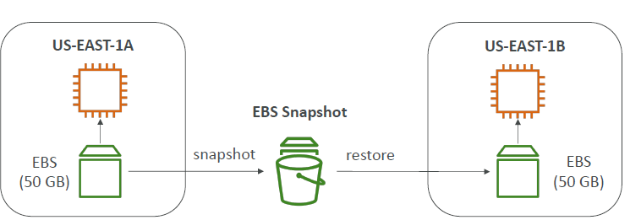

### EBS snapshot features

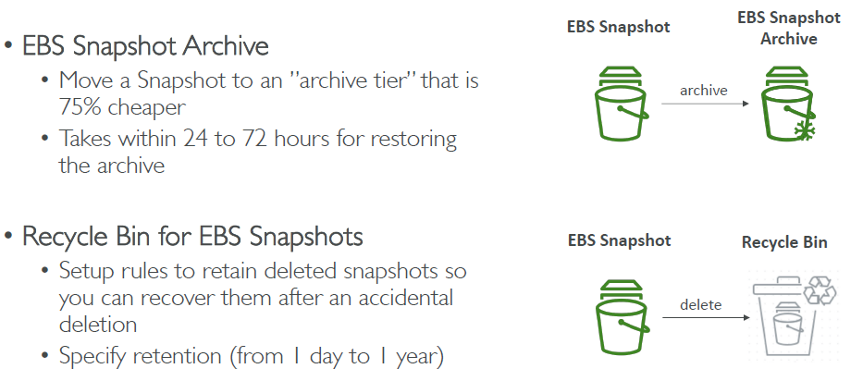

### EBS volume types:

• EBS Volumes come in 6 types

• gp2 / gp3 (SSD): General purpose SSD volume that balances price and performance for

a wide variety of workloads

• io1 / io2 (SSD): Highest-performance SSD volume for mission-critical low-latency or

high-throughput workloads

• st1 (HDD): Low cost HDD volume designed for frequently accessed, throughputintensive

workloads

• sc1 (HDD): Lowest cost HDD volume designed for less frequently accessed workloads

• EBS Volumes are characterized in Size | Throughput | IOPS (I/O Ops Per Sec)

• When in doubt always consult the AWS documentation – it’s good!

• Only gp2/gp3 and io1/io2 can be used as boot volumes (boot volumes- where the OS Is going to be running)

#### EBS volume type usecases:

##### General purpose SSD:

• Cost effective storage, low-latency

• System boot volumes, Virtual desktops, Development and test environments

• 1 GiB - 16 TiB

• gp3:

• Baseline of 3,000 IOPS and throughput of 125 MiB/s

• Can increase IOPS up to 16,000 and throughput up to 1000 MiB/s independently

• gp2:

• Small gp2 volumes can burst IOPS to 3,000

• Size of the volume and IOPS are linked, max IOPS is 16,000

• 3 IOPS per GB, means at 5,334 GB we are at the max IOPS

Summary: You remember, that in gp2/gp3,

this is for cost-effective storage latency.,

And in gp3 you can independently set the IOPS,

and the throughputs,

whereas for gp2, they're linked together.

##### Provisioned IOPS (PIOPS) SSD:

• Critical business applications with sustained IOPS performance

• Or applications that need more than 16,000 IOPS

• Great for databases workloads (sensitive to storage perf and consistency)

• io1/io2 (4 GiB - 16 TiB):

• Max PIOPS: 64,000 for Nitro EC2 instances & 32,000 for other

• Can increase PIOPS independently from storage size

• io2 have more durability and more IOPS per GiB (at the same price as io1)

• io2 Block Express (4 GiB – 64 TiB):

• Sub-millisecond latency

• Max PIOPS: 256,000 with an IOPS: GiB ratio of 1,000:1

• Supports EBS Multi-attach

###### EBS multi attach IO1/IO2 family:

**Important:** generally a EBS can only attached to one EC2 instance, but EBS of IO1 and IO2 family have multi attach quality to connect with multiple instances at the same time

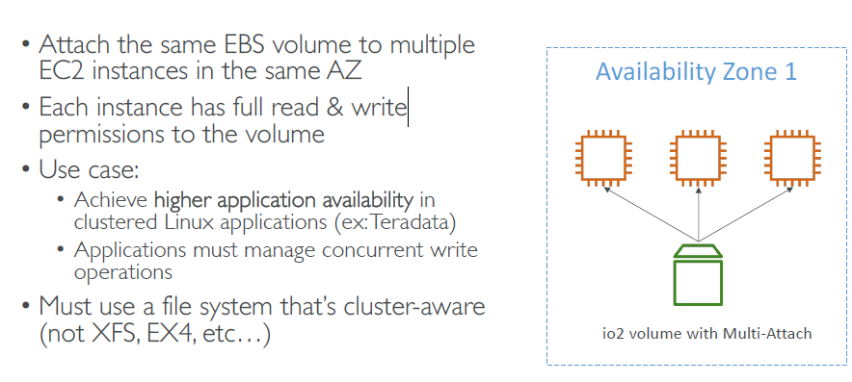

##### HDD Hard Disk Drives:

• Cannot be a boot volume

• 125 GiB to 16 TiB

• Throughput Optimized HDD (st1)

• Big Data, Data Warehouses, Log Processing

• Max throughput 500 MiB/s – max IOPS 500

• Cold HDD (sc1):

• For data that is infrequently accessed

• Scenarios where lowest cost is important

• Max throughput 250 MiB/s – max IOPS 250

### EBS encryption:

• When you create an encrypted EBS volume, you get the following:

• Data at rest is encrypted inside the volume

• All the data in flight (in transport) moving between the instance and the volume is encrypted

• All snapshots are encrypted

• All volumes created from the snapshot

• Encryption and decryption are handled transparently (you have nothing to

do)

• Encryption has a minimal impact on latency

• EBS Encryption leverages keys from KMS (AES-256)

• Copying an unencrypted snapshot allows encryption

• Snapshots of encrypted volumes are encrypted

### AMI overview:

• AMI = Amazon Machine Image

• AMI are a customization of an EC2 instance

• You add your own software, configuration, operating system, monitoring…

• Faster boot / configuration time because all your software is pre-packaged

• AMI are built for a specific region (and can be copied across regions)

• You can launch EC2 instances from:

• A Public AMI: AWS provided

• Your own AMI: you make and maintain them yourself

• An AWS Marketplace AMI: an AMI someone else made (and potentially sells)

#### Creating custom AMI from an existing AMI, which is used to create an EC2 instance:

• Start an EC2 instance and customize it

• Stop the instance (for data integrity)

• Build an AMI – this will also create EBS snapshots

• Launch instances from other AMIs

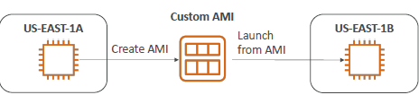

## EC2 instance store:

• EBS volumes are network drives with good but “limited” performance

**• If you need a high-performance hardware disk,** use EC2 Instance Store

• Better I/O performance

• EC2 Instance Store lose their storage if they’re stopped (ephemeral)

• Good for buffer / cache / scratch data / temporary content

• **Risk of data loss if hardware fails**

• **Backups and Replication are your responsibility**

in short words if you need a **very high performance hardware attached volume (hardware attached means the physical server where EC2 instance is stored, the storage is assigned in the same server AFAIK) for EC2 instances, you go to EC2 instance stores**

## Availability and Scalability:

• Scalability means that an application / system can handle greater loads

by adapting.

• There are two kinds of scalability:

• Vertical Scalability

• Horizontal Scalability (= elasticity)

• Scalability is linked but different to High Availability

• Let’s deep dive into the distinction, using a call center as an example

### Vertical Scalability:

You are trying to upgrade the instance size, ex: If you promote junior operator to senior operator

• Vertically scalability means increasing the size

of the instance

• For example, your application runs on a

t2.micro

• Scaling that application vertically means

running it on a t2.large

• Vertical scalability is very common for non

distributed systems, such as a database.

• RDS, ElastiCache are services that can scale

vertically.

• There’s usually a limit to how much you can

vertically scale (hardware limit)

### Horizontal scalability:

You try to increase the instances without changing its capacity, for example- you have 10 junior operators, you take another 10 junior operators to handle the increased workload

• Horizontal Scalability means increasing the

number of instances / systems for your

application

• Horizontal scaling implies distributed systems.

• This is very common for web applications /

modern applications

• It’s easy to horizontally scale thanks the cloud

offerings such as Amazon EC2

### High availability:

• High Availability usually goes hand in

hand with horizontal scaling

• High availability means running your

application / system in at least 2 data

centers (== Availability Zones)

• The goal of high availability is to survive

a data center loss

• The high availability can be passive (for

RDS Multi AZ for example)

• The high availability can be active (for

horizontal scaling)

### high availability and scaling for EC2:

• Vertical Scaling: Increase instance size (= scale up / down)

• From: t2.nano - 0.5G of RAM, 1 vCPU

• To: u-12tb1.metal – 12.3 TB of RAM, 448 vCPUs

• Horizontal Scaling: Increase number of instances (= scale out / in)

• Auto Scaling Group

• Load Balancer

• High Availability: Run instances for the same application across multi AZ

• Auto Scaling Group multi AZ

• Load Balancer multi AZ

## Load Balancers:

Load Balances are servers that **forward and distribute traffic** to multiple

servers (e.g., EC2 instances) downstream

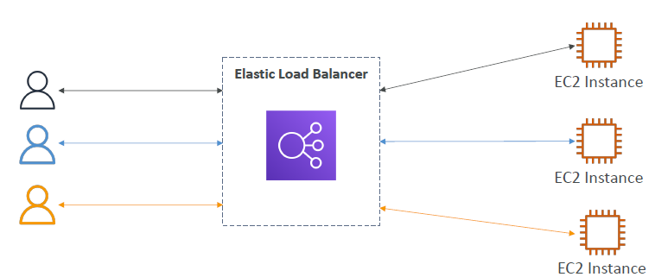

### Why Use a load balancer LB:

• Spread load across multiple downstream instances

• Expose a single point of access (DNS) to your application

• Seamlessly handle failures of downstream instances

• Do regular health checks to your instances

• Provide SSL termination (HTTPS) for your websites

• Enforce stickiness with cookies

• High availability across zones

• Separate public traffic from private traffic

### Why to use an Elastic Load Balancer ELB:

• An Elastic Load Balancer is a managed load balancer

• AWS guarantees that it will be working

• AWS takes care of upgrades, maintenance, high availability

• AWS provides only a few configuration knobs

• It costs less to setup your own load balancer but it will be a lot more effort

on your end to manage – configure upgrade, maintain

• It is integrated with many AWS offerings / services

• EC2, EC2 Auto Scaling Groups, Amazon ECS

• AWS Certificate Manager (ACM), CloudWatch

• Route 53, AWS WAF, AWS Global Accelerator

### Health checks:

ELB perform health checks to check whether the instance is properly working or not, if not it will send

• Health Checks are crucial for Load Balancers

• They enable the load balancer to know if instances it forwards traffic to

are available to reply to requests

• The health check is done on a port and a route (/health is common)

• If the response is not 200 (OK), then the instance is unhealthy

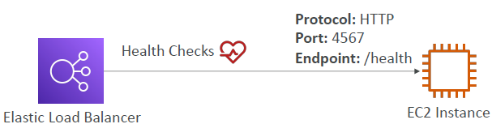

## Types of Elastic Load Balancers on AWS:

• AWS has 4 kinds of managed Load Balancers

• Classic Load Balancer (v1 - old generation) – 2009 – CLB **- deprecated**

• HTTP, HTTPS, TCP, SSL (secure TCP)

• Application Load Balancer (v2 - new generation) – 2016 – ALB

• HTTP, HTTPS, WebSocket

• Network Load Balancer (v2 - new generation) – 2017 – NLB

• TCP, TLS (secure TCP), UDP

• Gateway Load Balancer – 2020 – GWLB

• Operates at layer 3 (Network layer) – IP Protocol

• Overall, it is recommended to use the newer generation load balancers as they

provide more features

• Some load balancers can be setup as internal Load Balancer (private – **used for internal purposes**) or external Load Balancers (public – **used for websites or public applications**) ELBs

### Classic Load Balancer:

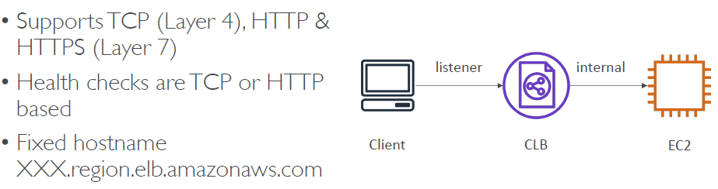

### Application load Balancer:

• Application load balancers is Layer 7 (HTTP)

• Load balancing to multiple HTTP applications across machines (target groups)

• Load balancing to multiple applications on the same machine (ex: containers)

• Support for HTTP/2 and WebSocket

• Support redirects (from HTTP to HTTPS for example)

• Routing tables to different target groups:

• Routing based on path in URL (example.com/users & example.com/posts)

• Routing based on hostname in URL (one.example.com & other.example.com)

• Routing based on Query String, Headers (example.com/users?id=123&order=false)

• ALB are a **great fit for micro services & container-based application (example: Docker & Amazon ECS)**

• Has a port mapping feature to redirect to a dynamic port in ECS

• **In comparison, we’d need multiple Classic Load Balancer’s per application**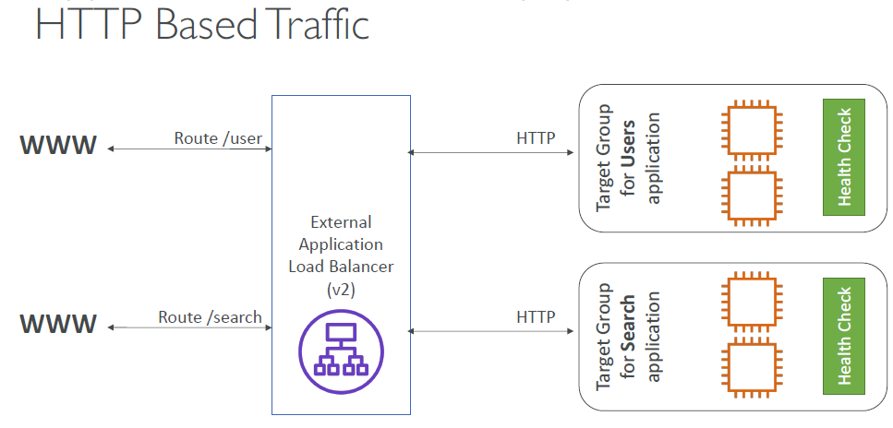

#### Target Groups:

Target groups are the services to where the traffic that comes out of the load balancers GO, below are the target groups for load balancers

• EC2 instances (can be managed by an Auto Scaling Group) – HTTP

• ECS tasks (managed by ECS itself) – HTTP

• Lambda functions – HTTP request is translated into a JSON event

• IP Addresses – must be private IPs

• ALB can route to multiple target groups

• Health checks are at the target group level

#### Query Strings/Parameters Routing:

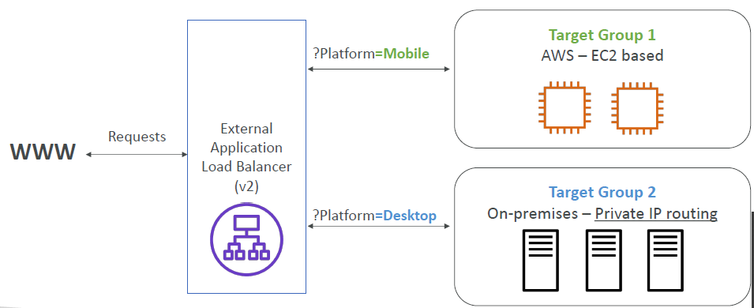

**Here if you closely notice in the above diagram itself you have ec2 instances (made out of AMI,also have IAM roles ) which have health check made in to target groups with security groups and on premise servers with security groups and also EAB, this itself shows how can we enhance our services needs with the help of cloud.**

The red color components above are the services which we can use in AWS

#### Good to know things on ALB:

• Fixed hostname (XXX.region.elb.amazonaws.com)

• The application servers don’t see the IP of the client directly

• The true IP of the client is inserted in the header X-Forwarded-For

• We can also get Port (X-Forwarded-Port) and proto (X-Forwarded-Proto)

To understand X-Forward part, see below image- client talks with the load balancer (blue circle) through client IP, and Load balancer talks with EC2 instance through load balancer IP, which is a private IP, for EC2 instance to know about Client IP, the EC2 instance has to look out to extra headers in the HTTP request (that it receives), which are called X-Forwarded-Port and X-forwarded-proto

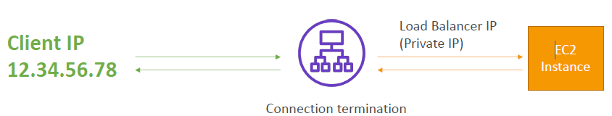

### Network Load Balancer NLB:

• Network load balancers (Layer 4) allow to:

• **Forward TCP & UDP traffic to your instances (refer below image where it accepts requests from TCP)**

• Handle millions of requests per seconds

• Less latency ~100 ms (vs 400 ms for ALB)

• NLB has **one static IP per AZ, and supports assigning Elastic IP**

(helpful for whitelisting specific IP)

• NLB are used for extreme performance, TCP or UDP traffic

• Not included in the AWS free tier

#### TCP layer4 Based traffic

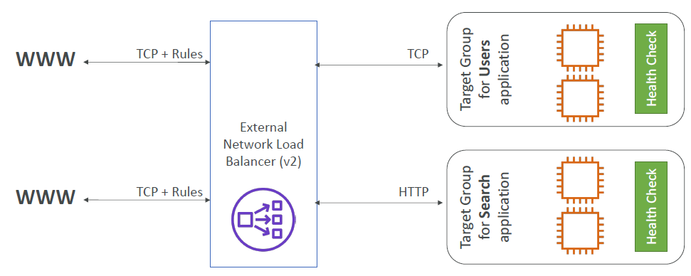

#### Target groups:

• EC2 instances

• IP Addresses – must be private IPs

• Application Load Balancer (ALB is also used when you want to allow some functionality of Network load balancer by making ALB as target group for NLB)

Target Groups section will have all the instances (let it be an EC2 or server) in the **Registered targets section** of **targets** option in **Target Groups section** of **EC2**

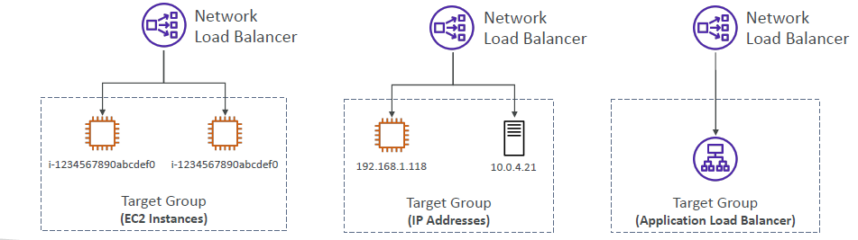

#### Important concept related to NLB:

Whenever there is an issue in request access (ex: entering URL through browser) to an Instance, possible issue might be with security groups related to it, if the status of target groups (which are linked to NLB) is **unhealthy**, that means instance is not responding to server, such problem might arise with NLB because NLB allows TCP requests, so far the security groups related to instance are only handling HTTP requests, in order to make use of NLB, we need to add a new rule to security group allowing TCP requests.

**Order of flow of request**

load balancer -> security group -> instance

### gateway load balancer:

not discussed in learning path

### sticky sessions (session affinity)

• It is possible to implement stickiness so that the same client is always redirected to the same instance behind a load balancer

• This works for **Classic Load Balancers & Application Load Balancers**

• The “cookie” used for stickiness has an expiration date you control

• **Use case: make sure the user doesn’t lose his session data**

• **Enabling stickiness may bring imbalance to the load over the backend EC2 instances (because the very purpose of load balancer is lost when requests are going to a specific instance)**

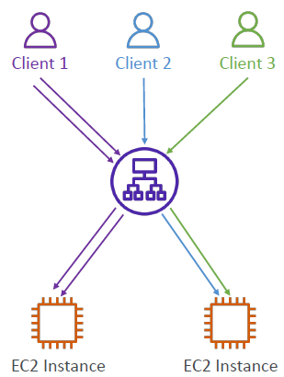

#### Cookie names:

• Application-based Cookies

• Custom cookie

• Generated by the target

• Can include any custom attributes required by the application

• Cookie name must be specified individually for each target group

• Don’t use AWSALB, AWSALBAPP, or AWSALBTG (reserved for use by the ELB)

• Application cookie

• Generated by the load balancer

• Cookie name is AWSALBAPP

• Duration-based Cookies

• Cookie generated by the load balancer

• Cookie name is AWSALB for ALB, AWSELB for CLB

### Cross Zone load balancing:

With Cross Zone Load Balancing:

each load balancer instance distributes evenly across all registered instances in all AZ

Without Cross Zone Load Balancing:

Requests are distributed in the instances of the node of the Elastic Load Balancer

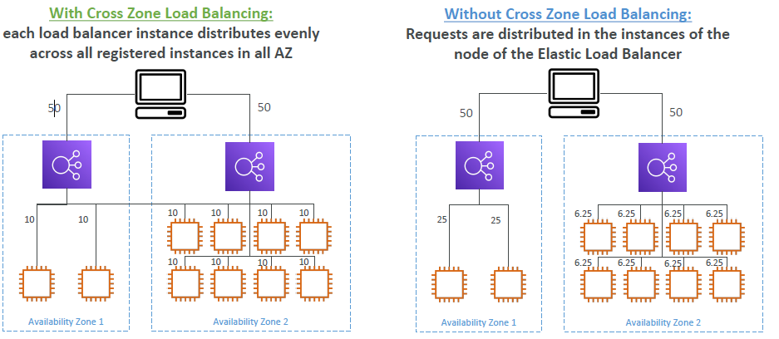

#### Cross Zone Load Balancing for different Load Balancers

• Application Load Balancer

• Always on (can’t be disabled)

• No charges for inter AZ data

• Network Load Balancer

• Disabled by default

• You pay charges ($) for inter AZ data if enabled

• Classic Load Balancer

• Disabled by default

• No charges for inter AZ data if enabled

### Load Balancer Certificates -SSL / TLS:

#### Basics:

• An SSL Certificate allows traffic between your clients and your load balancer

to be encrypted in transit (in-flight encryption)

• SSL refers to Secure Sockets Layer, used to encrypt connections

• TLS refers to Transport Layer Security, which is a newer version

• Nowadays, TLS certificates are mainly used, but people still refer as SSL

• Public SSL certificates are issued by Certificate Authorities (CA)

• Comodo, Symantec, GoDaddy, GlobalSign, Digicert, Letsencrypt, etc…

• SSL certificates have an expiration date (you set) and must be renewed

#### SSL certificates:

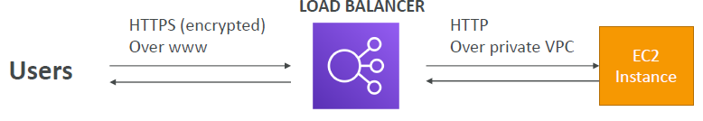

• The load balancer uses an X.509 certificate (SSL/TLS server certificate)

• You can manage certificates using ACM (AWS Certificate Manager)

• You can create upload your own certificates alternatively

• HTTPS listener:

• You must specify a default certificate

• You can add an optional list of certs to support multiple domains

• Clients can use SNI (Server Name Indication) to specify the hostname they reach

• Ability to specify a security policy to support older versions of SSL / TLS (legacy clients)

#### SNI Server Name Indication:

• SNI solves the problem of loading multiple SSL certificates onto one web server (to serve

multiple websites)

• It’s a “newer” protocol, and requires the client to indicate the hostname of the target server in the initial SSL handshake

• The server will then find the correct certificate, or return the default one

Note:

• Only works for ALB & NLB (newer generation), CloudFront

• Does not work for CLB (older gen)

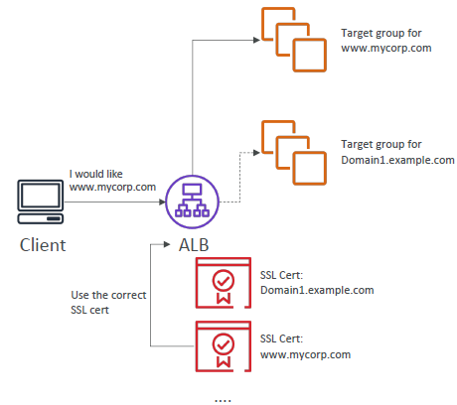

#### SSL certificates supported by various load balancers:

• Classic Load Balancer (v1)

• Support only one SSL certificate

• Must use multiple CLB for multiple hostname with multiple SSL certificates

• Application Load Balancer (v2)

• Supports multiple listeners with multiple SSL certificates

• Uses Server Name Indication (SNI) to make it work

• Network Load Balancer (v2)

• Supports multiple listeners with multiple SSL certificates

• Uses Server Name Indication (SNI) to make it work

### Connection Draining:

• Feature naming

• Connection Draining – for CLB

• Deregistration Delay – for ALB & NLB

• Time to complete “in-flight requests” while the instance is de-registering or unhealthy

• Stops sending new requests to the EC2 instance which is de-registering

• Between 1 to 3600 seconds (default: 300 seconds)

• Can be disabled (set value to 0)

• Set to a low value if your requests are short

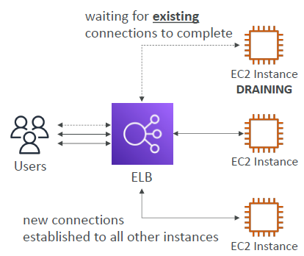

### Auto Scaling Group ASG:

**LSB and ASG go hand in hand**

• In real-life, the load on your websites and application can change

• In the cloud, you can create and get rid of servers very quickly

• The goal of an Auto Scaling Group (ASG) is to:

• Scale out (add EC2 instances) to match an increased load

• Scale in (remove EC2 instances) to match a decreased load

• Ensure we have a minimum and a maximum number of machines running

• Automatically Register new instances to a load balancer

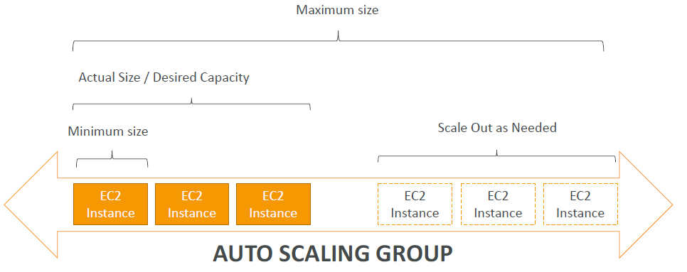

#### ASG in AWS with ELB:

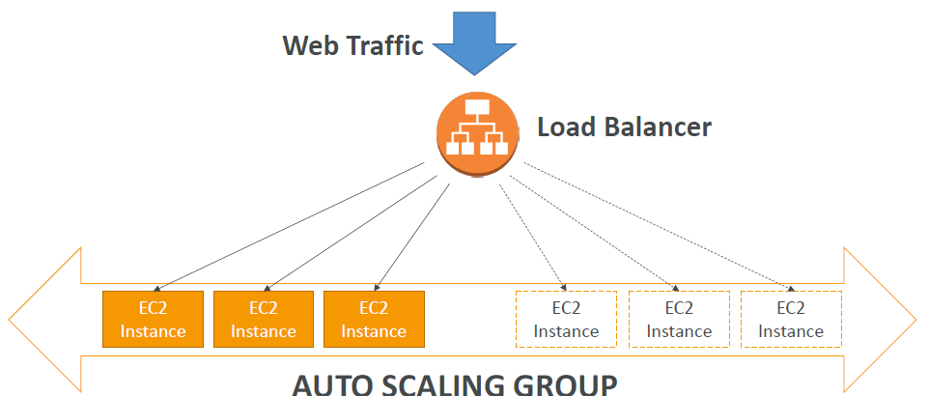

#### Attributes in ASG:

• A launch configuration

• AMI + Instance Type

• EC2 User Data

• EBS Volumes

• Security Groups

• SSH Key Pair

• Min Size / Max Size / Initial Capacity

• Network + Subnets Information

• Load Balancer Information

• Scaling

#### Auto Scaling Alarms:

• It is possible to scale an ASG based on CloudWatch alarms

• An Alarm monitors a metric (such as Average CPU)

• Metrics are computed for the overall ASG instances

• Based on the alarm:

• We can create scale-out policies (increase the number of instances)

• We can create scale-in policies (decrease the number of instances

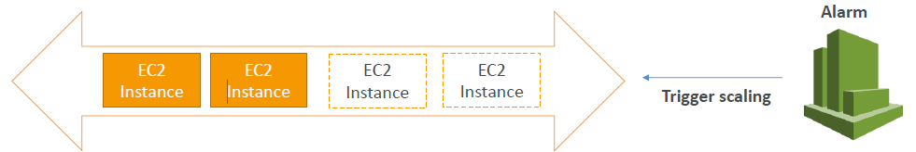

#### New Rules in Auto scaling:

• It is now possible to define ”better” auto scaling rules that are directly managed by EC2

• Target Average CPU Usage

• Number of requests on the ELB per instance

• Average Network In

• Average Network Out

• These rules are easier to set up and can make more sense

#### Using Custom metrics in Auto scaling:

• We can auto scale based on a custom metric (ex: number of connected users)

• 1. Send custom metric from application on EC2 to CloudWatch (PutMetric API)

• 2. Create CloudWatch alarm to react to low / high values

• 3. Use the CloudWatch alarm as the scaling policy for ASG

#### Summary of ASG- A brain dump:

• Scaling policies can be on CPU, Network… and can even be on custom metrics or

based on a schedule (if you know your visitors patterns)

• ASGs use Launch configurations or Launch Templates (newer)

• To update an ASG, you must provide a new launch configuration / launch template

• IAM roles attached to an ASG will get assigned to EC2 instances

• ASG are free. You pay for the underlying resources being launched

• Having instances under an ASG means that if they get terminated for whatever reason,

the ASG will automatically create new ones as a replacement. Extra safety!

• ASG can terminate instances marked as unhealthy by an LB (and hence replace them)

#### ASG- Dynamic Scaling Groups:

• Target Tracking Scaling (this will create cloud watch alarm for us)

• Most simple and easy to set-up

• Example: I want the average ASG CPU (utilisation) to stay at around 40%

• Simple / Step Scaling

• When a CloudWatch alarm is triggered (example CPU (utilisation) > 70%), then add 2 units

• When a CloudWatch alarm is triggered (example CPU (utilisation) < 30%), then remove 1

• Scheduled Actions

• Anticipate a scaling based on known usage patterns

• Example: increase the min capacity to 10 at 5 pm on Fridays

#### ASG- Predictive Scaling:

Predictive scaling: continuously forecast load and schedule scaling ahead (can become popular, because of ML implementation) 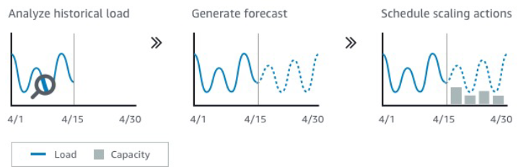

#### Some of the metrics to consider while deciding the scaling:

• CPUUtilization: Average CPU utilization across your instances

• RequestCountPerTarget: to make sure the number of requests per EC2

instances is stable

• Average Network In / Out (if you’re application is network bound)

• Any custom metric (that you push using CloudWatch)

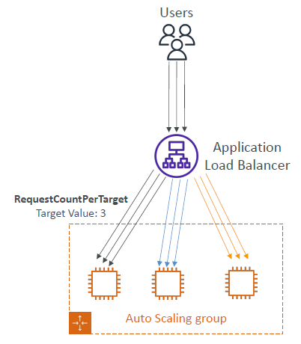

#### ASG- Scaling Cool downs:

• After a scaling activity happens, you are in the cooldown period (default 300 seconds)

• During the cooldown period, the ASG will not launch or terminate additional instances (to allow for metrics to stabilize)

• Advice: Use a ready-to-use AMI to reduce configuration time in order to be serving request fasters and reduce the cooldown

Period

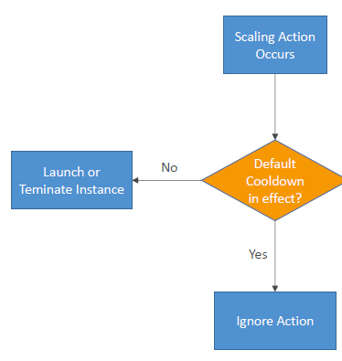

#### ASG for solution architects:

• ASG Default Termination Policy

(simplified version):

1. Find the AZ which has the

most number of instances

2. If there are multiple instances

in the AZ to choose from,

delete the one with the

oldest launch configuration

• ASG tries the balance the

number of instances across AZ

by default

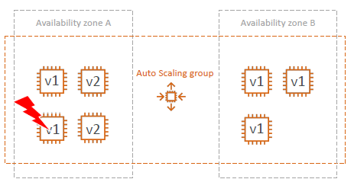

##### ASG Solution architects for lifecycle hooks:

• By default as soon as an

instance is launched in an

ASG it’s in service.

• You have the ability to

perform extra steps before

the instance goes in service

(Pending state)

• You have the ability to

perform some actions before

the instance is terminated

(Terminating state)



##### Launch template vs launch configuration:

• Both:

• ID of the Amazon Machine Image (AMI), the instance type, a key pair, security groups, and the other parameters that you use to launch EC2 instances (tags, EC2 user-data...)

• Launch Configuration (legacy):

• Must be re-created every time

• Launch Template (newer):

• Can have multiple versions

• Create parameters subsets (partial configuration for re-use and inheritance)

• Provision using both On-Demand and Spot instances (or a mix)

• Can use T2 unlimited burst feature

• Recommended by AWS going forward

## Load Balancer Security Groups:

The Load Balancer is outside the instances, so it is important to see that the load balancer should only filter the requests from a source that EC2 wants, so we mention the Security Group rules that we want in **Instance** to **ELB** and then mention the ELB as source to Instance, observe the image below. This is an **Enhanced Security Mechanism**

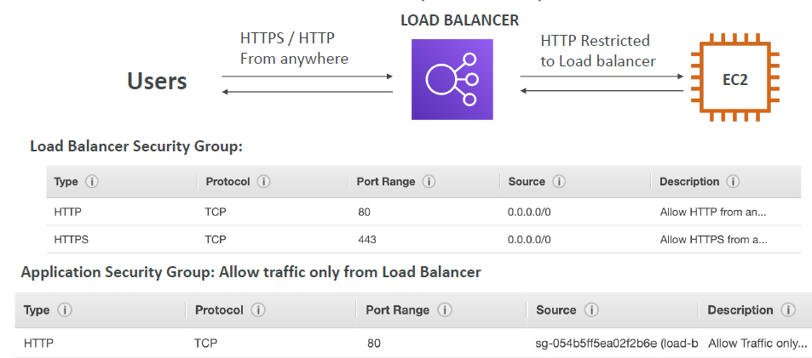

## AWS RDS overview:

• RDS stands for Relational Database Service

• It’s a managed DB service for DB use SQL as a query language.

• It allows you to create databases in the cloud that are managed by AWS

• Postgres

• MySQL

• MariaDB

• Oracle

• Microsoft SQL Server

• Aurora (AWS Proprietary database)

### Advantage over using RDS vs deploying DB on EC2:

• RDS is a managed service:

• Automated provisioning, OS patching

• Continuous backups and restore to specific timestamp (Point in Time Restore)!

• Monitoring dashboards

• Read replicas for improved read performance

• Multi AZ setup for DR (Disaster Recovery)

• Maintenance windows for upgrades

• Scaling capability (vertical and horizontal)

• Storage backed by EBS (gp2 or io1)

• BUT you can’t SSH into your instances

### RDS backups:

• Backups are automatically enabled in RDS

• Automated backups:

• Daily full backup of the database (during the maintenance window)

• Transaction logs are backed-up by RDS every 5 minutes

• => ability to restore to any point in time (from oldest backup to 5 minutes ago)

• 7 days retention (can be increased to 35 days)

• DB Snapshots:

• Manually triggered by the user

• Retention of backup for as long as you want

### Storage Auto Scaling:

• Helps you increase storage on your RDS DB instance

dynamically

• When RDS detects you are running out of free database

storage, it scales automatically

• Avoid manually scaling your database storage

• You have to set Maximum Storage Threshold (maximum limit

for DB storage)

• Automatically modify storage if:

• Free storage is less than 10% of allocated storage

• Low-storage lasts at least 5 minutes

• 6 hours have passed since last modification

• Useful for applications with unpredictable workloads

• Supports all RDS database engines (MariaDB, MySQL,

PostgreSQL, SQL Server, Oracle)

### Read replicas vs multi AZ:

• Up to 5 Read Replicas

• Within AZ, Cross AZ

or Cross Region

• Replication is ASYNC,

so reads are eventually

consistent

• Replicas can be

promoted to their

own DB

• Applications must

update the connection

string to leverage read

replicas

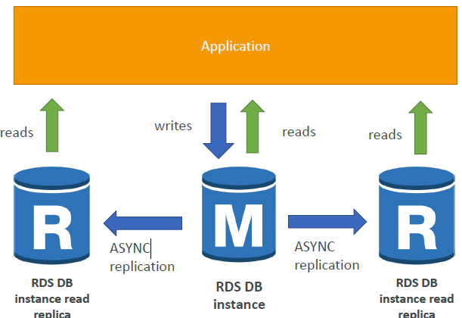

#### Network cost:

• In AWS there’s a network cost when data goes from one AZ to another

• For RDS Read Replicas within the same region, you don’t pay that fee

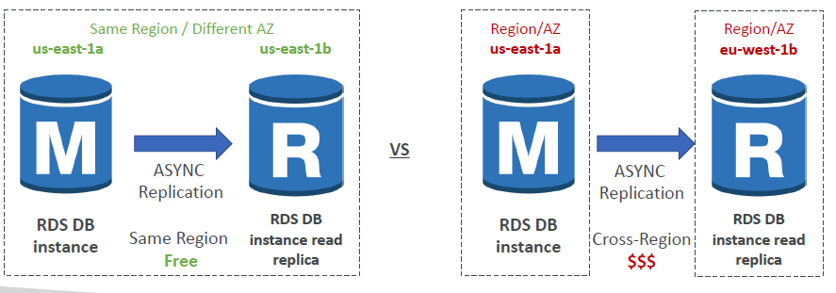

#### Multi AZ:

• SYNC replication done across **different zones**

• One DNS name – automatic app

failover to standby

• Increase availability

• Failover in case of loss of AZ, loss of

network, instance or storage failure

• No manual intervention in apps

• Not used for scaling

• Multi-AZ replication is **free**

• **Note:The Read Replicas be setup as Multi AZ for Disaster Recovery (DR)**

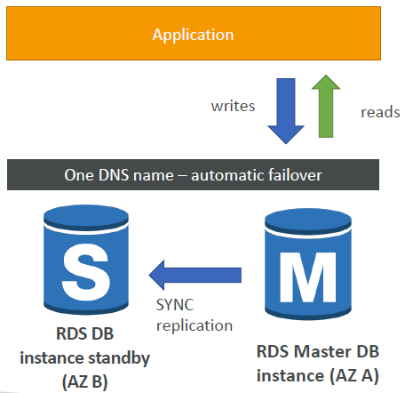

#### From single AZ to multiple AZ:

**Zero downtime operation** (no need to stop the DB)

• Just click on “**modify**” for the Database **and enable “Multi AZ”**

• The following happens internally:

• A snapshot is taken

• A new DB is restored from the snapshot in a new AZ

• Synchronization is established between the two databases

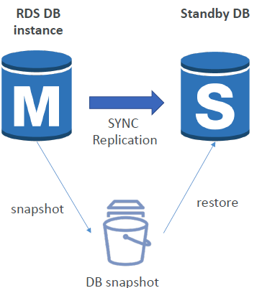

### RDS security

#### Encryption:

• At rest encryption

• Possibility to encrypt the master & read replicas with AWS KMS - AES-256 encryption

• Encryption has to be defined at launch time

• **If the master is not encrypted, the read replicas cannot be encrypted**

• **Transparent Data Encryption (TDE) available for Oracle and SQL Server**

• In-flight encryption

• SSL certificates to encrypt data to RDS in flight (**inflight encryption will always available with SSL**)

• Provide SSL options with trust certificate when connecting to database

• To enforce SSL:

• PostgreSQL: rds.force_ssl=1 in the AWS RDS Console (Parameter Groups)

• MySQL: Within the DB: GRANT USAGE ON *.* TO 'mysqluser'@'%' REQUIRE SSL;

#### Encryption operations:

• Encrypting RDS backups

• Snapshots of un-encrypted RDS databases are un-encrypted

• Snapshots of encrypted RDS databases are encrypted

• **Can copy an unencrypted snapshot into an encrypted one** (**steps below**)

• To encrypt an un-encrypted RDS database:

• Create a snapshot of the un-encrypted database

• Copy the snapshot and enable encryption for the snapshot

• Restore the database from the encrypted snapshot

• Migrate applications to the new database, and delete the old database

#### Network & IAM:

• Network Security

• RDS databases are usually deployed within a private subnet, not in a public one

• RDS security works by leveraging security groups (the same concept as for EC2

instances) – it controls which IP / security group can communicate with RDS

• Access Management

• IAM policies help control who can manage AWS RDS (through the RDS API)

• Traditional Username and Password can be used to login into the database

• **IAM-based authentication can be used to login into RDS MySQL & PostgreSQL**

##### IAM authentication:

• IAM database authentication works with MySQL and PostgreSQL

• You don’t need a password, just an authentication token obtained through IAM & RDS API calls

• Auth token has a lifetime of 15 minutes

• Benefits:

• Network in/out must be encrypted using SSL

• IAM to centrally manage users instead of DB

• Can leverage IAM Roles and EC2 Instance profiles for easy integration

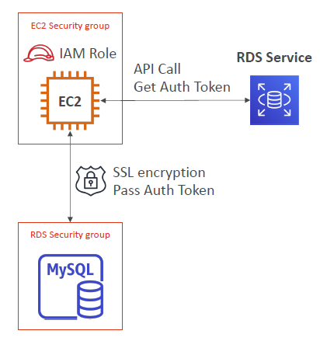

#### RDS Summary:

• Encryption at rest:

• Is done only when you first create the DB instance

• or: unencrypted DB => snapshot => copy snapshot as encrypted => create DB from snapshot

• Your responsibility:

• Check the ports / IP / security group inbound rules in DB’s SG

• In-database user creation and permissions or manage through IAM

• Creating a database with or without public access

• Ensure parameter groups or DB is configured to only allow SSL connections

• AWS responsibility:

• No SSH access

• No manual DB patching

• No manual OS patching

• No way to audit the underlying instance

## S3:

### Introduction:

• Amazon S3 is one of the **main building blocks of AWS**

• It’s advertised as ”**infinitely scaling**” storage

• It’s **widely popular** and deserves its own section

• **Many websites use Amazon S3 as a backbone**

• **Many AWS services uses** **Amazon S3 as an integration** as well

* S3 is not a **global service**, it is a **global console**

### Buckets and Objects:

#### Buckets:

• Amazon S3 allows people to store **objects (files)** in **“buckets” (directories)**

• Buckets must have a **globally unique name**

• Buckets are **defined at** the **region level**

• Naming convention

• No uppercase

• No underscore

• 3-63 characters long

• Not an IP

• Must start with lowercase letter or number

Encryption:

We can encrypt things at object level (a detailed explanation given below in section **s3 encryption for objects**) or bucket level by configuring after creating buckets by going in to **properties** tab -> **default encryption -> edit**

#### Objects:

• Objects (files) have a Key

• The key is the FULL path:

• s3://my-bucket/my_file.txt

• s3://my-bucket/my_folder1/another_folder/my_file.txt

• The key is composed of prefix + object name

• s3://my-bucket/my_folder1/another_folder/my_file.txt

• **There’s no concept of “directories” within buckets (although the UI will trick you to think otherwise)** **the objects are just keys with very long names that contain slashes (“/”)**

• Object values are the content of the body:

• Max Object Size is 5TB (5000GB)

• If uploading more than 5GB, must use “multi-part upload”

• Metadata (list of text key / value pairs – system or user metadata)

• Tags (Unicode key / value pair – up to 10) – useful for security / lifecycle

• Version ID (if versioning is enabled)

#### Hands on Learnings:

If a bucket is not public, you can not access the object using object URL, you can access only it using **pre-signed URL (pre signed URL – gives access to certain files to certain users for a limited amount of time)**, which means the URL that also has temporary credentials, this can be clicking on open option

### Versioning:

• You can version your files in Amazon S3

• It is enabled at the bucket level

• Same key overwrite will increment the “version”: 1, 2, 3….

• It is **best practice to version your buckets**

• **Protect against unintended deletes** (ability to restore a version)

• **Easy roll back** to previous version

• Notes:

• **Any file that is not versioned prior to enabling versioning will have version “null”**

• **Suspending versioning does not delete the previous versions**

#### Hands onlearnings:

* if you upload the same file twice keeping the versioning on, then also you can see only one file, if you click on the file, you can see the old version as well, if you delete the newer version (it will be the only one displayed on UI, which is updated in the place of old one), if you toggle on the list version, you can see entries and their corresponding version id of first upload, second upload and **delete marker** (this is the type that is allotted to deleted files), **deleting the objects with list version toggle off will not delete them, but it just gives an impression of them being deleted, which is not actually true in reality, in other words, the object is not actually deleted unless you get the “warning of permanent deletion “ or if it prompts for “permanent delete”**
* now, if you want to restore the **first uploaded file**, **activate list versions** toggle then you want to delete the delete marker and the second version, this will **permanently delete** the files

### s3 encryption for objects:

• There are 4 methods of encrypting objects in S3

• SSE-S3: encrypts S3 objects using keys handled & managed by AWS

• SSE-KMS: leverage AWS Key Management Service to manage encryption keys

• SSE-C: when you want to manage your own encryption keys

• Client Side Encryption

• It’s important to understand which ones are adapted to which situation for the exam

#### SSE-S3:

An encryption key that Amazon S3 creates, manages, and uses for you. [Learn more](https://docs.aws.amazon.com/console/s3/using-sse-encryption-s3-managed)

• SSE-S3: encryption using keys handled & managed by Amazon S3

• Object is encrypted server side

• AES-256 encryption type

• Must set header: “x-amz-server-side-encryption": "AES256" (x-amz stands for x-amazon)

• **can send http or https req+ header**

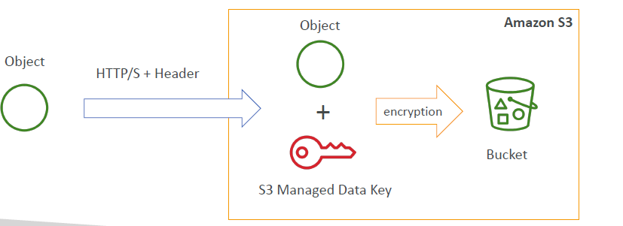

#### SSE-KMS:

• SSE-KMS: encryption using keys handled & managed by KMS

• KMS Advantages: user control (who has access to what keys )+ audit trail

• Object is encrypted server side

• Must set header: “x-amz-server-side-encryption": ”aws:kms"

Options we get for KMS in AWS:

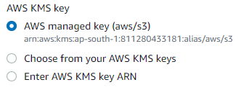

AWS managed key is seamless (which will make an api call to AWS KMS service)

• **can send http or https req+ header**

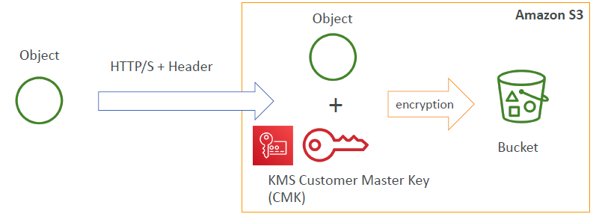

#### SSE-C:

• SSE-C: server-side encryption using data keys fully managed by the customer outside of AWS

• Amazon S3 does not store the encryption key you provide

• **HTTPS must be used**

• Encryption key must provided in HTTP headers, for every HTTP request made

##### Points to be noted:

* SSE-C: it’s full form literally means Server Side Encryption -Client side data key
* They key is not stored in the server after the encryption completes
* To retrieve the object you need to pass the same client side data key(key that you passed in header for encryption) in the header

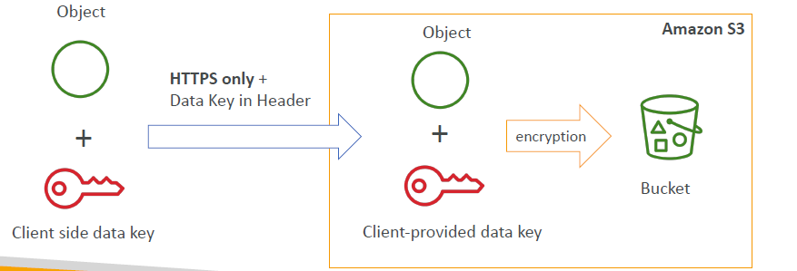

#### Client side Encryption:

• Client library such as the Amazon S3 Encryption Client

• Clients must encrypt data themselves before sending to S3

• Clients must decrypt data themselves when retrieving from S3, i.e., clients are **responsible** for decryption

• Customer fully manages the keys and encryption cycle

• **can send http or https req**

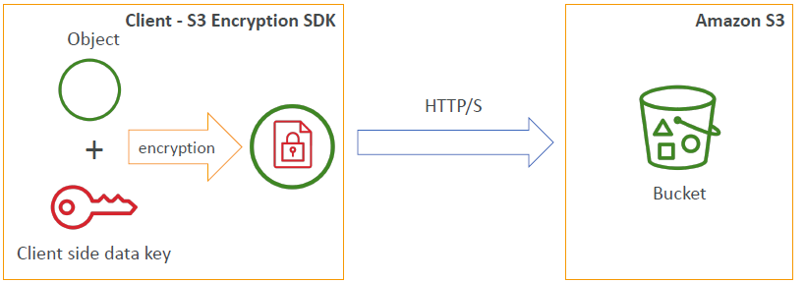

#### Encryption in transit:

• Amazon S3 exposes:

• HTTP endpoint: non encrypted

• HTTPS endpoint: encryption in flight

• You’re **free to use the endpoint you want, but HTTPS is recommended**

• **Most clients would use the HTTPS endpoint by default**

• **HTTPS is mandatory for SSE-C**

• **Encryption in flight is also called SSL / TLS**

#### **S3 Security:**

• User based

• IAM policies - which API calls should be allowed for a specific user from IAM console

• Resource Based

• Bucket Policies - bucket wide rules from the S3 console - allows cross account

• Object Access Control List (ACL) – finer grain

• Bucket Access Control List (ACL) – less common

• Note: an IAM principal can access an S3 object if

• the user IAM permissions allow it OR the resource policy ALLOWS it

• If IAM permissions allow access to S3 and if the S3 Bucket is denying because of its Bucker Policy, that means you can not access the bucket, because the Bucket policy is given priority

##### S3 Bucket policies:

• JSON based policies

• Resources: buckets and objects

• Actions: Set of API to Allow or Deny

• Effect: Allow / Deny

• Principal: The account or user to apply the policy to

• Use S3 bucket for policy to:

• Grant public access to the bucket

• Force objects to be encrypted at upload

• Grant access to another account (Cross Account)



The above policy implies, public read (principal-* means policy is applicable to every one), effect- allow i.e., action: get object, therefore, get object is allowed for everyone, resource: examplebucket/*, therefore, get object is allowed for example bucket and anyone can perform this operation (detailed explanation of every key is in above rules)

##### Bucket setting for block public access:

Bucket settings for blocking public access came in to picture, because there were data leaks from S3 Buckets

To block public access of all my buckets you can go to services->s3->account settings for block [ublic access (side bar) ->click on edit ->check block all public access

• Block public access to buckets and objects granted through

• new access control lists (ACLs)

• any access control lists (ACLs)

• new public bucket or access point policies

• Block public and cross-account access to buckets and objects through any public bucket or access point policies

• These settings were created to prevent company data leaks

• If you know your bucket should never be public, leave these on

• Can be set at the account level

##### Other information:

• Networking:

• Supports VPC Endpoints (for instances in VPC without www internet i.e., **instances can private access in to buckets with VPC without the need of internet**)

• Logging and Audit:

• S3 Access Logs can be stored in other S3 bucket

• API calls can be logged in AWS CloudTrail

• User Security:

• MFA Delete: MFA (multi factor authentication) can be required in versioned

buckets to delete objects

• Pre-Signed URLs: URLs that are valid only for a limited time (ex: premium video

service for logged in users)

##### s3 websites:

we can also host websites with S3: properties-> Static website hosting

• S3 can host static websites and have them accessible on the www

• The website URL will be:

• <bucket-name>.s3-website-<AWS-region>.amazonaws.com

OR

• <bucket-name>.s3-website.<AWS-region>.amazonaws.com

• If you get a 403 (Forbidden) error, make sure the bucket policy allows public reads! (check bucket setting for block public access and turn it off)

##### Consistency of S3 buckets:

• Strong consistency as of December 2020:

• After a:

• successful write of a new object (new PUT)

• or an overwrite or delete of an existing object (overwrite PUT or DELETE)

• …any:

• subsequent read request immediately receives the latest version of the object (read after write consistency)

• subsequent list request immediately reflects changes (list consistency)

• Available at no additional cost, without any performance impact

#### S3- Moving Between Storage classes:

• You can transition objects between storage classes

• For infrequently accessed object, move them to STANDARD_IA

• For archive objects you don’t need in real-time, GLACIER or DEEP_ARCHIVE

• Moving objects can be automated using a lifecycle configuration

* **Transitioning small objects into glacier deep archive or glacier archive can increase costs**



#### S3-Life cycle rules

• Transition actions: It defines when objects are transitioned to another storage

class.

• Move objects to Standard IA class 60 days after creation

• Move to Glacier for archiving after 6 months

• Expiration actions: configure objects to expire (delete) after some time

• Access log files can be set to delete after a 365 days

• Can be used to delete old versions of files (if versioning is enabled)

• Can be used to delete incomplete multi-part uploads

• Rules can be created for a certain prefix (ex - s3://mybucket/mp3/*)

• Rules can be created for certain objects tags (ex - Department: Finance)

##### Scenario-1:

• Your application on EC2 creates images thumbnails after profile photos

are uploaded to Amazon S3. These thumbnails can be easily recreated,

and only need to be kept for 45 days. The source images should be able

to be immediately retrieved for these 45 days, and afterwards, the user

can wait up to 6 hours. How would you design this?

• S3 source images can be on STANDARD, with a lifecycle configuration

to transition them to GLACIER after 45 days.

• S3 thumbnails can be on ONEZONE_IA (**as they can be easily recreated**), with a lifecycle configuration

to expire them (delete them) after 45 days.

##### Scenario 2:

• A rule in your company states that you should be able to recover your

deleted S3 objects immediately for 15 days, although this may happen rarely.

After this time, and for up to 365 days, deleted objects should be recoverable

within 48 hours.

• You need to enable S3 versioning in order to have object versions, so that

“deleted objects” are in fact hidden by a “delete marker” and can be

recovered

• You can transition these “noncurrent versions” of the object to S3_IA

• You can transition afterwards these “noncurrent versions” to

DEEP_ARCHIVE

## Serverless:

• Serverless is a new paradigm in which the developers don’t have to manage servers anymore…

• They just deploy code

• They just deploy… functions !

• Initially... Serverless == FaaS (Function as a Service)

• Serverless was pioneered by AWS Lambda but now also includes

anything that’s managed: “databases, messaging, storage, etc.”

• Serverless does not mean there are no servers…

it means you just don’t manage / provision / see them

### serverless services supported in AWS:

• AWS Lambda

• DynamoDB

• AWS Cognito

• AWS API Gateway

• Amazon S3

• AWS SNS & SQS

• AWS Kinesis Data Firehose

• Aurora Serverless

• Step Functions

• Fargate

### Why AWS Lambda?

Amazon EC2

• Virtual Servers in the Cloud

• Limited by RAM and CPU

• Continuously running

• Scaling means intervention to add / remove servers

Amazon Lambda

• Virtual functions – no servers to manage!

• Limited by time - short executions

• Run on-demand

• Scaling is automated!

#### Benefits of AWS Lambda:

• Easy Pricing:

• Pay per request and compute time

• Free tier of 1,000,000 AWS Lambda requests and 400,000 GBs of compute time

• Integrated with the whole AWS suite of services

• Integrated with many programming languages

• Easy monitoring through AWS CloudWatch

• Easy to get more resources per functions (up to 10GB of RAM!)

**• Increasing RAM will also improve CPU and network!**

#### Aws lambda language support:

• Node.js (JavaScript)

• Python

• Java (Java 8 compatible)

• C# (.NET Core)

• Golang

• C# / Powershell

• Ruby

• Custom Runtime API (community supported, example Rust)

• Lambda Container Image

• The container image must implement the Lambda Runtime API

• **ECS / Fargate is preferred for running arbitrary Docker images**

#### Main AWS lambda integrations:

* API gateway: to create REST API’s that invoke lambda functions
* Kinesis: to do some data transformations on the fly
* DynamoDB: to create some triggers whenever there is something happening in our DB, a lambda function will be triggered
* S3- a lambda function can be created anytime for almost any task in S3, ex: trigger lambda function when a file is created
* Cloud front: lambda@edge (not understood)
* Cloudwatch event or cloudwatch bridge: when something happens in AWS infrastructure, we should be able to react

Ex: we have cut pipeline state changes, we have to do some actions based on it.

* Cloudwatch logs: to stream logs wherever you want
* SNS (Simple Notification Service): to react to your notifications on SNS topics
* SQS (Simple Queuing Services): to process Messages from your SQS queues
* Cognito: to react whenever … (not understood)

Ex: whenever user logs in to database

* **There are many other lambda integrations,**

##### Ex: serverless thumbnail creation:

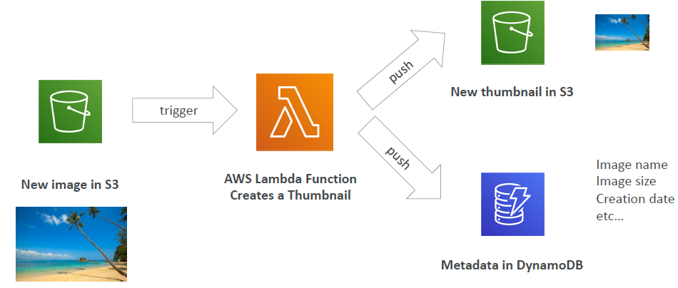

##### Server less cron job:

Cron: used on EC2 or any virtual server, if you want to generate jobs every 5 minutes, you need to set up cron job on vierual server or EC2, and as long as your instance is not running, your cron job is not doing anything, **instead you can create a cloudwatch rule or event bridge, that will be triggered every hour and wil be integrated with a lambda function, which performs your task in a totally serverless manner**

#### **Aws lambda pricing:**

• You can find overall pricing information here:

https://aws.amazon.com/lambda/pricing/

• Pay per calls:

• First 1,000,000 requests are free

• $0.20 per 1 million requests thereafter ($0.0000002 per request)

• Pay per duration: (in increment of 1 ms)

• 400,000 GB-seconds of compute time per month for FREE

• == 400,000 seconds if function is 1GB RAM

• == 3,200,000 seconds if function is 128 MB RAM

• After that $1.00 for 600,000 GB-seconds

• It is usually very cheap to run AWS Lambda so it’s very popular

#### AWS lambda limits to know per region (might be asked for exam):

• Execution:

• Memory allocation: 128 MB – 10GB (1 MB increments)

• Maximum execution time: 900 seconds (15 minutes)

• Environment variables (4 KB)

• Disk capacity in the “function container” (in /tmp): 512 MB

• Concurrency executions: 1000 (can be increased)

• Deployment:

• Lambda function deployment size (compressed .zip): 50 MB

• Size of uncompressed deployment (code + dependencies): 250 MB

• Can use the /tmp directory (**if the above 2 points does not hold good, consider storing them in temp directory**) to load other files at startup

• Size of environment variables: 4 KB

## VPC:

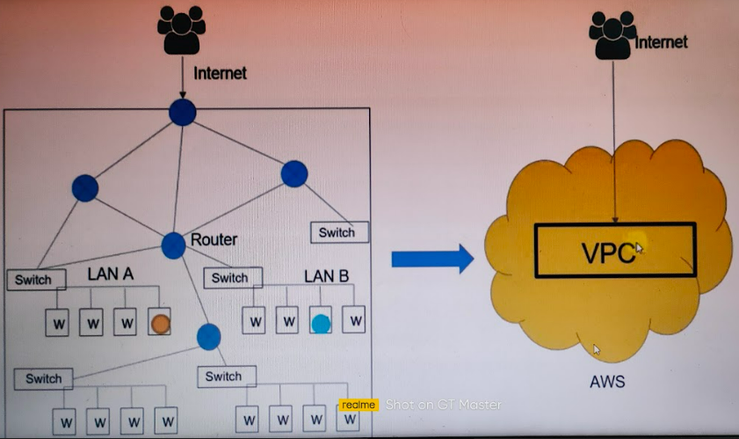

Traditional network (left) VPC (right)  
In a local network (the one in the left) if machines (w) in the same lAN needs to communicate, then they can communicate using mac address, the switch attached to the LAN will transfer packets, if machines across LAN wants to connect, ex: machine from LAN A to machine in LAN B, then machine in LAN A -> switch -> Router -> switch (connected to LAN B) -> LAN B -> Machine in LAN B,

If a machine in LAN needs to connect to Internet then it has to connect to Router that is connected to Internet

Vpc: Amazon Virtual Private Cloud (Amazon VPC) enables you to launch Amazon

Web Services (AWS) resources into a virtual network that you've defined. This

virtual network closely resembles a traditional network that you'd operate in your

own data center, with the benefits of using the scalable infrastructure of AWS.

Internet gateway: it allows 2 way traffic -> ingress and outgress

NAT gateway: 1 way traffic -> Outside of it.

### Traditional IT network vs VPC

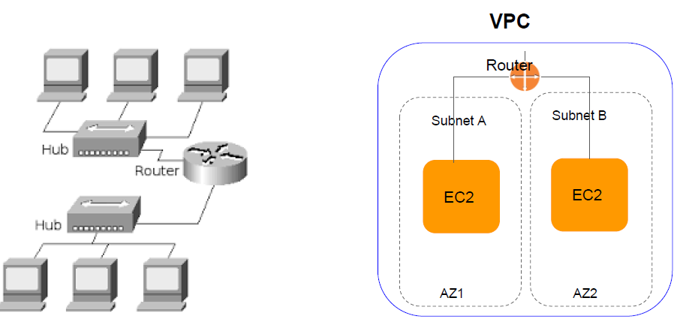

Router in VPC: controls traffic in and out of VPC

### Hierarchy in AWS Accounts, Users, Regions, and Services:

Each level of below flow can do different set of works which can only be done at a particular level.

Account-> Region -> VPC (s) -> AZ

Works done at a particular level:

First level -> Account- works done at account level - ex: DNS service (route 53)

Second level -> Region (s)-> ex: S3, CDN (cloud front), SNS , Lambda, DynamoDB, SQS, API gateway

Third level -> VPC (s) -> ex: ELB

Fourth level -> AZ (s) -> EC2, RDS

Refer below diagram to check levels

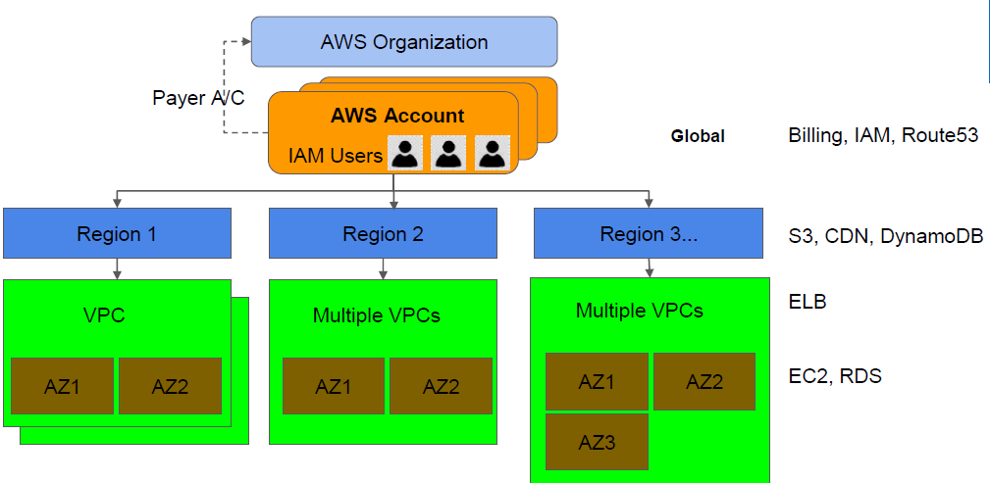

### VPC in Application architecture:

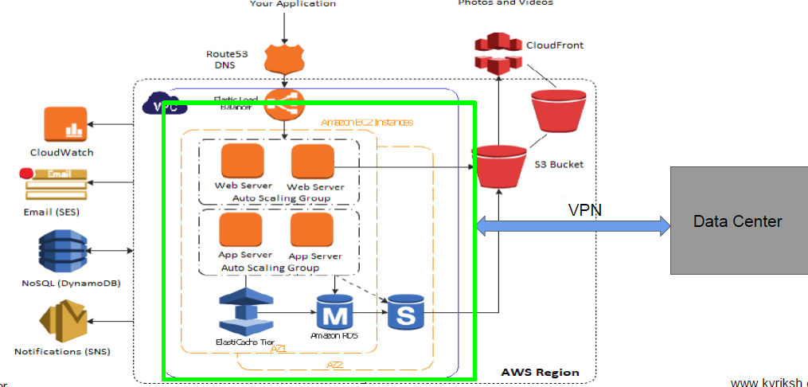

### AWS services inside and outside VPC:

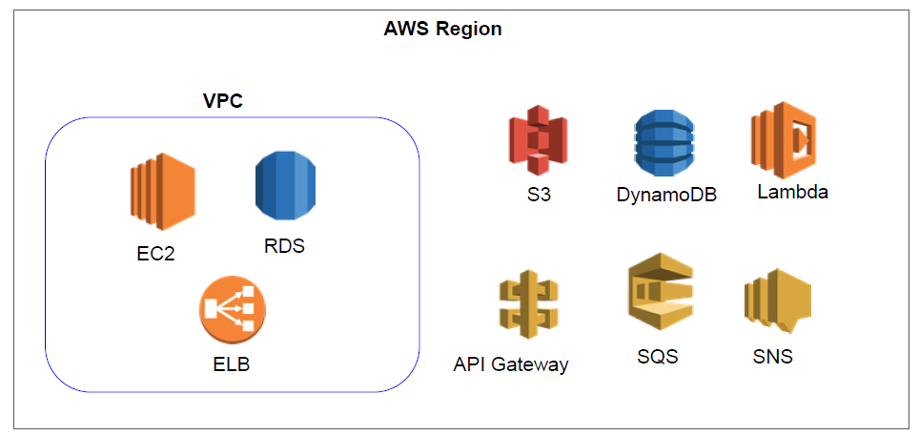

### Components of VPC:

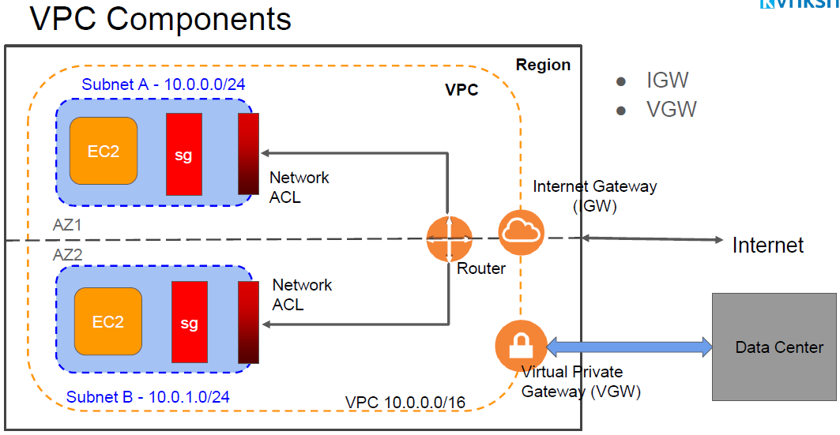

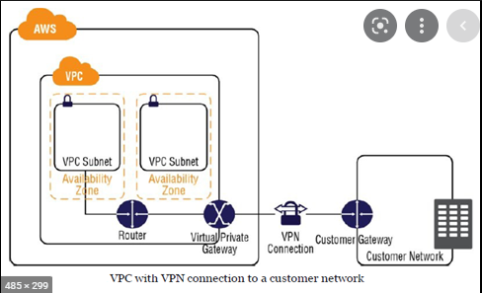

VPC- Virtual Private Cloud

Each subnet or VPC is named using CIDR – Classless Inter Domain Routing : used for assigning addresses to VPC or Subnets, in above image, you can see subnets and VPC have same naming convention

Subnets- Big VPC address space or region is further divided in to smaller parts called subnets so that they can be further divided in to private or public needs , they are named using CIDR

Route tables: takes routing decisions based on how traffic should go, each VPC will have one Route table **and it always has one local route and target of the route will be VPC CIDR (because the CIDR of all the subnets will be coming under VPC, this can be confirmed by the target of the route table that is stored as local route)**, so it will handle traffic from one subnet to another with out any need of outside routers as they are both inside the VPC

**Routers use Routing Tables** to determine out which interface the packet will be sent.

Internet Gateway (IGW): by default, a VPC is not connected to the internet, to connect to internet a VPC can only connect through internet gateway

NACL: Network access Control Lists – an optional layer of security that acts as firewall for controlling traffic in and out of one or more subnets, you might setup network ACL’s rules similar to your security group to make it an additional layer of security to your VPC

Customer Gateway (CGW) or Virtual Private Gateway (VGW): Virtual Private Gateway (VPG) is a VPN concentrator (provides secure creation of the VPN connection for to send messages between nodes), customer gateway (CGW) represents physical device or software application on the customer side of VPN connection

#### VPC addressing- understanding CIDR:

●Classless InterDomain Routing

Syntax: A.B.C.D/E -> A,B,C,D -> 16 bytes i.e., 2^16 i.e., 0-255 range

E -> number that ranges from 0-32

For an example 10.10.0.0/16 means

E=16, that means 2*8 -> first two 8 bits, i.e, A, B : 10.10 are **fixed** for **network**, the next two 8 bits, i.e., C,D : 0.0 is for **host** , host can change, so based on above notation, we can have CIDR values for subnets, VPC or hosts as follows:

10.10.0.0 to 10.10.255.255

●Example: 10.200.0.0/16

●VPC CIDR

○Maximum /16 (65536 IPs)

○Minimum /28 (16 IPs)

○VPC Private IP CIDR range

■10.0.0.0 -10.255.255.255 (10/8 prefix)

■172.16.0.0 -172.31.255.255 (172.16/12 prefix)

■192.168.0.0 -192.168.255.255 (192.168/16 prefix)

●Subnet CIDR

○Same as VPC

#### Route Table:

* Contains rules to route the traffic , in/out of Subnets/VPC
* Main route table at VPC level
* Custom route table at Subnet level
* Each route table contains default , immutable local route for VPC
* If no custom route table is defined , then new subnets are associated , with Main route table
* We can modify main route table
* **Route table just provides the route and is similar to ROAD, security groups are similar to Security Guard before a building, they will decide who will go and who wont based on some certain defined rules**

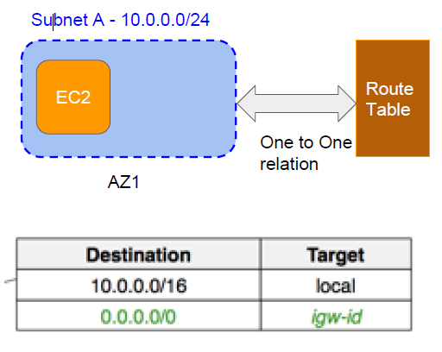

#### Subnets:

* Public Subnet
  + Has route for Internet
  + Instances with Public IP can communicate to,internet
  + Ex: NAT, Web servers, Load balancer
* Private Subnet
  + No route to Internet
  + Instances receives private IPs
  + Typically uses NAT for instances to have internet, access
  + Ex: Database, App server
* As discussed private subnets need NAT instances to have access to internet, the flow will be like this
  + Ec2 instance -> security Group -> Subnet Route table -> NAT -> IGW -> Internet
* **In edit subnet settings section, if you enable “auto-assign public IPv4 address” that means a new network interface or instance created inside this subnet will have a public ip assigned automatically**

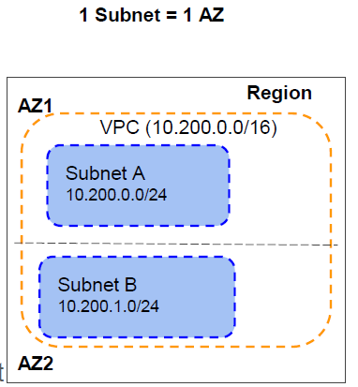

#### Security Groups:

* Virtual Firewall First level of defence
* Stateful-**No need to explicitly allow return traffic**
* **Works at EC2 and RDS level**
* Default allows all outbound traffic. No inbound traffic.
* Can attach upto 5 security groups to single EC2 instance with 100 rules (in/outbound) per SG
* Can only specify ALLOW rules.
* Deny rules can not be specified
* Changes to rules are in effect immediately
* When target is Security group, allow inbound connection to all instances associated with target security group

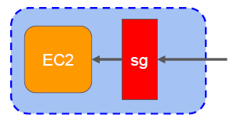

Example rules:

|  |  |  |  |
| --- | --- | --- | --- |
| **Type** | **Protocol** | **Port** | **Source** |
| HTTP | TCP | 80 | 0.0.0.0/0 |
| HTTPS | TCP | 443 | 0.0.0.0/0 |
| SSH | TCP | 22 | 180.151.138.43/32 |

#### Network Access Control List – NACL:

* Stateless (both inbound and outbound has to be mentioned) firewall - 2nd level of network security
* Works at Subnet level (all changes are) applied to all instances, ex: all ec2 instances in subnet
* Stateless
* Contains both Allow and Deny rules
* Rules are evaluated in the **order of rule number**
* Default NACL allows all inbound and outbound traffic

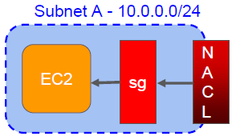

**NACL can be understood as the firewall or protection for the subnet. Security group can be understood as a firewall to protect EC2 instances.**

### **VPC analogy:**

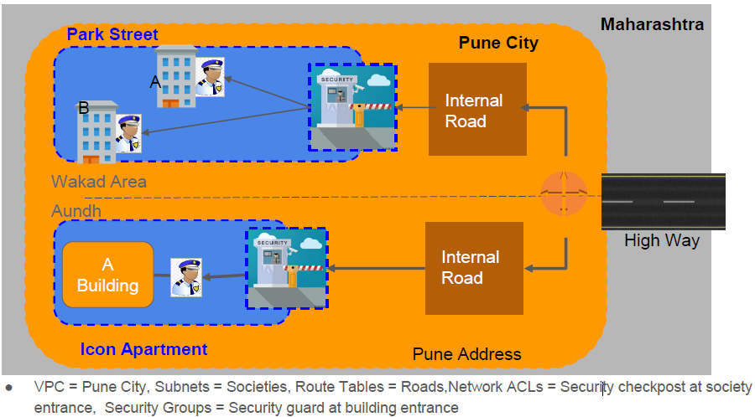

### Theoretical explanation of things in side VPC:

**Let us say there is VPC CIDR 10.10.0.0/16, then the VPC is further divided in to 2 subnets each subnet possible CIDR ID will be 10.10.0.0/24 and 10.10.1.0/24, as 10.10.0.0/24 and 10.10.0.1/14 both are in same VPC, the internal route table of the VPC can transfer data directly from one subnet to another using router, subnet 1 has 10.10.0.0/24 so if we create EC2 instance inside it, it having CIDR 10.10.0.5 is valid, 10.10.0.1, 10.10.0.2, 10.10.0.3, 10.10.0.15 cannot be assigned as they are reserved for some purposes**

**if you want to connect a private VPC to internet or to the outside of VPC, then you have to mention about it (it’s CIDR) to the route table and add corresponding directions related information, then only you can connect to internet or outside of VPC, also your EC2 instance cannot talk to internet because you have mentioned internet CIDR, you need to have a public IP in your EC2 instance so that you can receive packets from internet**

**by default all subnets in the VPC follow details that are there in the main route table, but if a subnet is public, then we need to add some CIDR to the Route table, this might disturb other subnets which are private, so we can have route table at the subnet level, this route table by default will have the VPC CIDR because to route the traffic locally(to other EC2 instances using private IP) you can only determine a instance is local or not by looking at the VPC CIDR**

**as soon you create a subnet inside VPC, then the existing connection of subnet (AZ) with the main route table breaks and all the traffic will just go in and out based on the conditions inside the routetable of the subnet (AZ) directly without any connection to main Route table**

## Network Address Translation (NAT):

(NAT – a device which makes the connection of internet to a instance from a private subnet in a amazon VPC (Virtual Private cloud)) + internet gateway (a proxy) in simple words instances in a private subnet connects to NAT and NAT communicates with the internet, to the outside world sees NAT as an originating server, it hides the ip address of the private subnet and replaces it with its own IP address, **as NAT is talking to internet it should be placed in public subnet, i.e., nat should be placed in a public subnet, for a private subnet to talk to internet through NAT gateway, Route table of that private subnet should be mentioned a rule for internet CIDR- 0.0.0.0/0 that if EC2 traffic for internet CIDR should be routed to NAT, else EC2 instance cannot talk to internet**

Basically, ping is just sending a packet (with various parts in it, along with source and destination address) and waiting for data in return from the packet

Explanation: a ping contains a lot of things along with source IP and destination IP, when a instance in a private subnet pings, then the request is routed to NAT there the source IP which is IP of EC2 instance is replaced by the IP of NAT and it tries to connect with Internet, so to the outside world it seems that NAT is the origin of the Ping, but in reality it isn’t. the response from destination IP is also managed in the same way.

Real world analogy of NAT is HAWALA

We can implement NAT in 2 ways in AWS ->1: NAT gateway – a fully managed gateway by AWS, 2: creating NAT from EC2 instance.

### NAT instance and NAT gateway:

* To provide Internet Access to instances in private subnet without IGW
* Performs Network Address translation when packet leaves the VPC

NAT Instance

* NAT EC2 can be launched using Amazon Linux Nat AMI
* Disable Source/Destination check on instance
* Allocate EIP

Nat Gateway:

* Managed by AWS
* Highly available with AZ

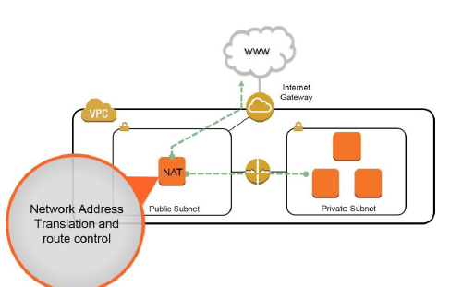

#### VPC with private subnet (that connects via nat to internet) and public subnet:

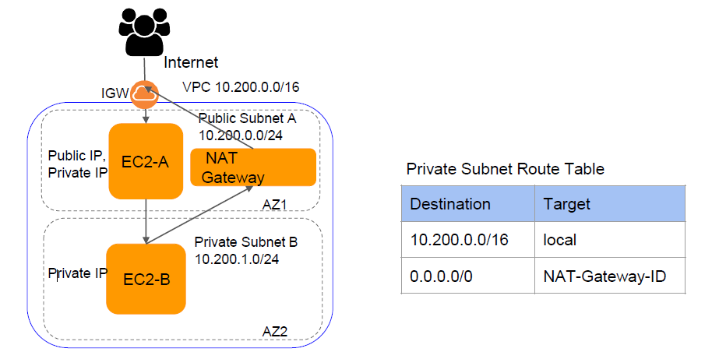

#### Setting up NAT on VC2:

Must be in Public Subnet

Must have Public or Elastic IP

Should be launched using AWS provided NAT AMIs (amzn ami vpc nat) Ex: amzn ami vpc nat hvm 2017.09.1.20180103 x86_64 ebs (ami 0c184c63)

Disable Source/Destination Check

Update Private subnet route tables. For internet traffic set target as NAT Instance ID

Reference: [NAT instances - Amazon Virtual Private Cloud](https://docs.aws.amazon.com/vpc/latest/userguide/VPC_NAT_Instance.html)

## Misc:

* A **key pair** is a security credentials which consists of public key and private key, and is used to prove your identity while trying to connect to an EC2 instance, public key will be stored in EC2 and user should store the private key
* Alarm high means scale out in automatic scaling groups, alarm low will scale in
* Same region- us-east-1a, us-east-1b are **same regions,** us-east-1a and us-west-1b are **cross regions**
* **KMS –** key management services
* **ARN-** Amazon resource
* **ACL –** access control list: another way to do read and writes at object level, in other words ACL is another way to protect objects in AWS
* if any service has tags, you can filter all the resources under that service using tags, ex if you have 10 ec2 instances, out of them if you want to filter ec2 instances with tag, you can search using tags i.e., owner as key and [saivinil.pratap@tigeranalytics](mailto:saivinil.pratap@tigeranalytics) as value, then search for
  + owner : [saivinil.pratap@tigeranalytics.com](mailto:saivinil.pratap@tigeranalytics.com)
* to connect to an instance through wsl they pem key should have chmod 400 permission, then ssh -i <pem key path> <username>@<**public** ipv4 address of instance>
* for an public ec2 instance in one subnet to connect with private instance in wnother subnet of same VPC, you need to connect through private key used for the VPC, ssh -i <pem key path> <username>@<**private** ipv4 address of instance(private instance with which we are trying to connect)> , now this opens private EC2 instance and you can execute any commands in the same way we did in the above step for a public EC2, in simple words **we logged in to private instance from a public instance**

## Topics not included:

* Amazon aurora, Elasticache